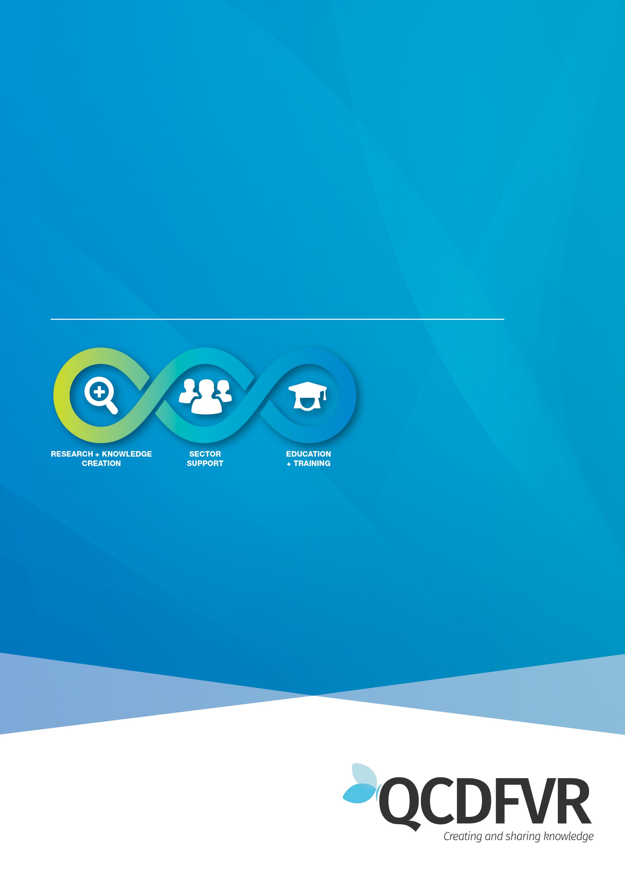

**Community of Practice** **peer support: 23/4/24**

**Women’s Health and Wellbeing Support Services**

**Community of Practice (WHW SS)– Peer Support 23/4/24**

**Topic for discussion** – Somatics

**Attendance –** 5 participants

**Notes from Discussion**

Initial discussion pending request to record peer support session for those missing it. Discussion pointed to maintaining the safe space of peer supports and not recording.

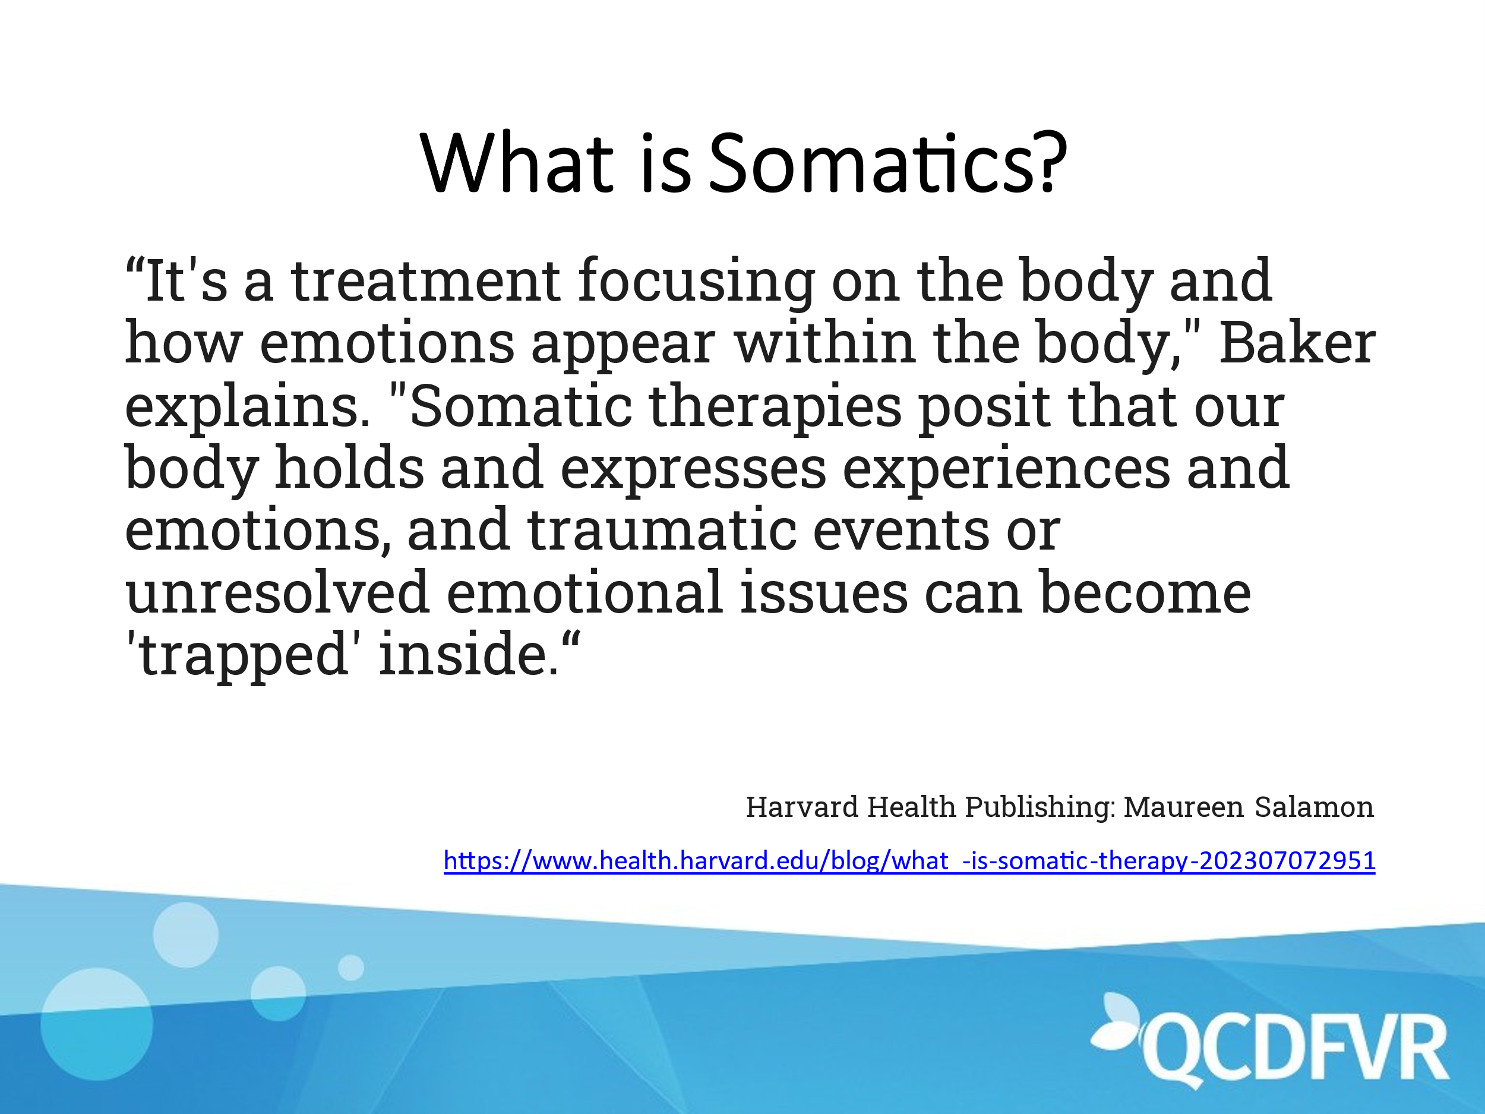

* Practitioners all stated that while they had used and learnt small amounts about Somatics, they had limited knowledge, and none claimed to be an expert.
* Definitions included releasing energy in the body trapped there by trauma as well as reconnecting mind, body, and emotions after dissociation from trauma.
* Practitioners spoke about some techniques they have used or have heard about including butterfly tapping, naming the experience, body scans, shaky hands.
* Some practitioners spoke about some hesitations in using this technique with certain clients, especially those who had experienced SV.
* Mention was made about needing to set up expectations in using somatics, clearly outlining what it is and how it works as some clients may push back not understanding it completely.
* Other practitioners some about hesitation to even attempt somatics and discussion was had about how to address barriers to new therapies or, on the other hand, applying a client cantered approach allowing each client to be unique in approach.
* Some hesitation was expressed in using somatics in group sessions.
* All practitioners expressed interest in learning more about Somatics and having someone present to the group about somatics – thus also accommodating those who were not able to attend this session.

Suggestions welcome for someone to present CoP session on Somatics:

* Expressive therapies
* Somatic Experiencing International
* ???

