

**Community of Practice:** **Peer Support, JUN 23**

**DFV Specialists within FACC and IFS**

Women’s Health and Wellbeing Support Services

**Peer Support notes – 13th June 2021**

**Attendance –** 19 participants

**Apologies – 2 declined invite**

**Topic for discussion** – Perpetrator mapping tool

**Initially, Margaret Kertesz from the Kody Project came to speak to the team to ask them if they are aware of any programs that currently address both DFV and AOD use. Participants were invited to contact Margaret if they think of anything in the future on** [**mkertesz@unimelb.edu.au**](mailto:mkertesz@unimelb.edu.au)

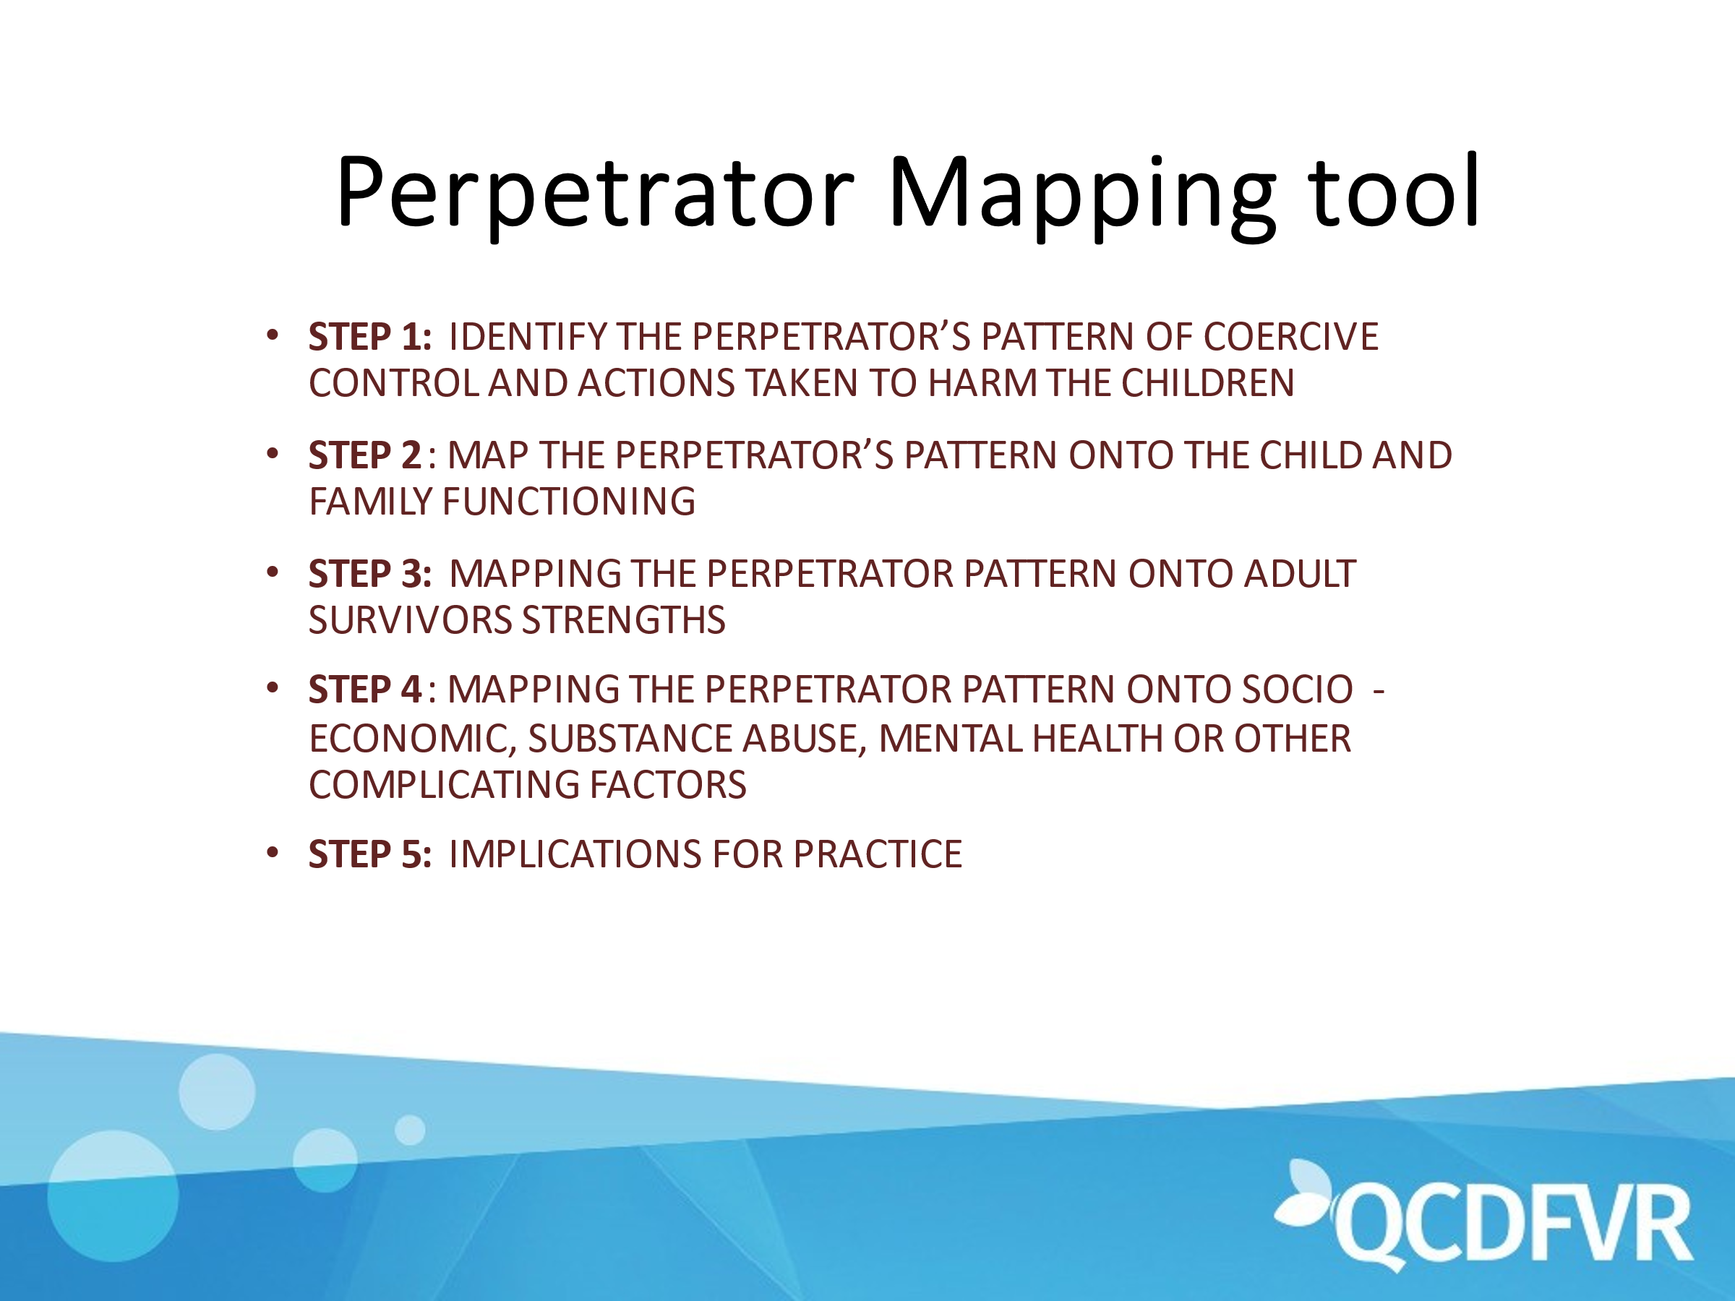

Participants were provided with a case study (see appendix A) then broken up into groups to compile answers to the first step:

*List the behaviours the perpetrator has engaged in to degrade child and family functioning. In this step you are outlining the perpetrator’s behaviour and statements (actions), not its impact on child and family functioning.*

Participants fed back to the main group example responses. (see example below from Safe and together training program)

* *Father has physically assaulted Mother multiple times over the last five years. The incidents of violence have included punching her in the face repeated in front of the children, causing bruising and one broken nose. He has pushed her against a wall, thrown dinner plates at her head, and threated her with a knife held against her throat.*
* *More than once, Father has threated to kill Mother, telling her he would “cut her throat” and “drag her into the woods to die.” He said this in front of their 5-year-old son.*
* *Father stalked Mother at work and at her parent’s house when they were separated three years ago. He would drive by both locations, honking the car horn. He smashed his car into her parents’ car, knocking off the side view mirror.*
* *Father has taken all the children out of the house, then called Mother demanding she give him money so he could buy meth, saying she would never see the children again if she doesn’t give him money.*
* *Father has punched multiple holes in the walls in the kitchen and living room when he was upset with someone in the family.*
* *Father kicked in the 13-year-old step daughter’s bedroom door when she ran away from him during the last incident. During this incident he called her a “stupid bitch who was just as dumb as her mother” and “threaten to kick her out onto the street.” He told that’s where a “raghead whore” like her belongs.*

Participants were then broken up again into groups to respond to step 2:

*Complete the following sentences:*

* *The perpetrator’s behaviour pattern caused the following trauma related effects on the children:*
* *The perpetrator’s behaviour pattern disrupted the family’s ecology in the following ways:*
* *The perpetrator’s behaviour pattern affected the other parent’s parenting in the following ways:*
* *How else did the perpetrator’s behaviour pattern impact child and family functioning*

Responses to this step were fed back to the group again similar to example below:

*The perpetrator’s behaviour pattern caused the following trauma related effects on the children:*

* *The 13-year-old girl has been getting into fights at school; she sometimes wants to sleep with her mother because she is afraid; she is fallen behind academically in school; there is also concerns that she might have started smoking marijuana.*
* *The five-year-old boy has speech impediment, stuttering when he is nervous. He is very clinging with her mother and has very difficult transitions from school to home.*
* *On more than one occasion the police reports indicate that both children were crying in their room when the police arrived.*

*The perpetrator’s behaviour pattern disrupted the family’s ecology in the following ways:*

* *The family has moved three times in the last few years as few years as result of Father’s violence: once one Mother fled to her parent’s house; once when they went into a refuge; and once when Father’s violence led the family to be evicted. This appears to have contributed to the 13 year’s old girls academic and behavioural issues.*
* *Mother reports she has lost her last two jobs because either Father showing up to work or harassing by phone or because she moved to get away from his violence. This reports that this has prevented her involving the children in afterschool activities and limiting other expenses related to the children.*
* *The 13-year-old has dropped out of counseling because Father says it costs too much money and it was “bullshit anyway.” The girl reports missing her counselor.*
* *Police reports, and interviews with Mother and the children indicate that whenever Father gets violent the children miss days at school and for days afterwards have trouble sleeping.*

*The perpetrator’s behaviour pattern affected the other parent’s parenting in the following ways:*

* *Mother reports that the children do not listen to her and often throwback in her face the same insults that Father uses against her: “you’re fat”, “you’re stupid.” The boy has called his mother a “raghead,” a slur that he has heard Father use against her.*
* *Mother reports that her depression returned after Father forced her and the children to move back with them after she felt like he was a threat to her parents (where they were living).*
* *Mother reports not wanting to the children to be alone with the Father because he might take them from her. She reports “I feel like a single parent because I’m afraid for him to be alone with the children, ever.” Mother reports being exhausted from managing the household and her fear of him taking the children.*

*How else did the perpetrator’s behaviour pattern impact child and family functioning?*

* *Father’s drug use has contributed to the family’s lack of housing and income stability.*

Participants were broken up into groups for a third time to respond to step 3:

*List as many behaviours as is known in this case in response to each sentence*

* *The adult survivor did ________ to promote safety of the children in response to the perpetrator’s coercive control and actions to harm the children. 4*
* *The adult survivor did ________ to promote healing from trauma of the children in response to the perpetrator’s coercive control and actions to harm the children.*
* *The adult survivor did ________ to promote stability and nurturance of the children in the face of perpetrator’s coercive control and actions to harm the children.*
* *What else did the adult survivor do to promote child and family functioning in the context of the perpetrator’s behaviour pattern?*

Responses to this step included those similar to this example:

*The adult survivor did ________ to promote safety of the children in response to the perpetrator’s coercive control and actions to harm the children.*

* *Sending them to room; trying to keep Father calm; lying to Father about things that might upset him as ways to keep the children physically safe.*
* *Taking the children to a refuge twice and moved in with her parents for extended periods of time when she was more worried about Father’s violence (usually when he was using).*
* *Until she lost her last job, paying for her daughter to play soccer and her son to be in after school program to minimize their exposure to their Father, and provide emotional safety.*
* *Repeatedly telling Father that his behaviour was bad for the children and demanded in he get help for his substance abuse and violence.*
* *Mother has called the police on three occasions to protect herself and her children.*
* *Mother keeps the children with her as much as possible in order to avoid Father using the children to control her.*
* *Mother has sought and received a court order to protect herself and her children.*

*The adult survivor did ________ to promote healing from trauma of the children in response to the perpetrator’s coercive control and actions to harm the children.*

* *Took both children to a therapist to get help.*
* *gotten counseling for herself so she can, in her words, “better help the children. If I’m strong they will do better.”*
* *Does daily check-ins with about their feelings and how their day is going.*
* *Talked to the counselors at the children’s schools about what is happening at home so they could help her children.*
* *Talks about how she tries to read to the 5 year old every night and does her best to get her daughter over to maternal grandparents house, as her daughter and her mother are very close*.

Unfortunately we ran out of time and were unable to continue with the last 2 steps however I have included the example responses from S and T training.

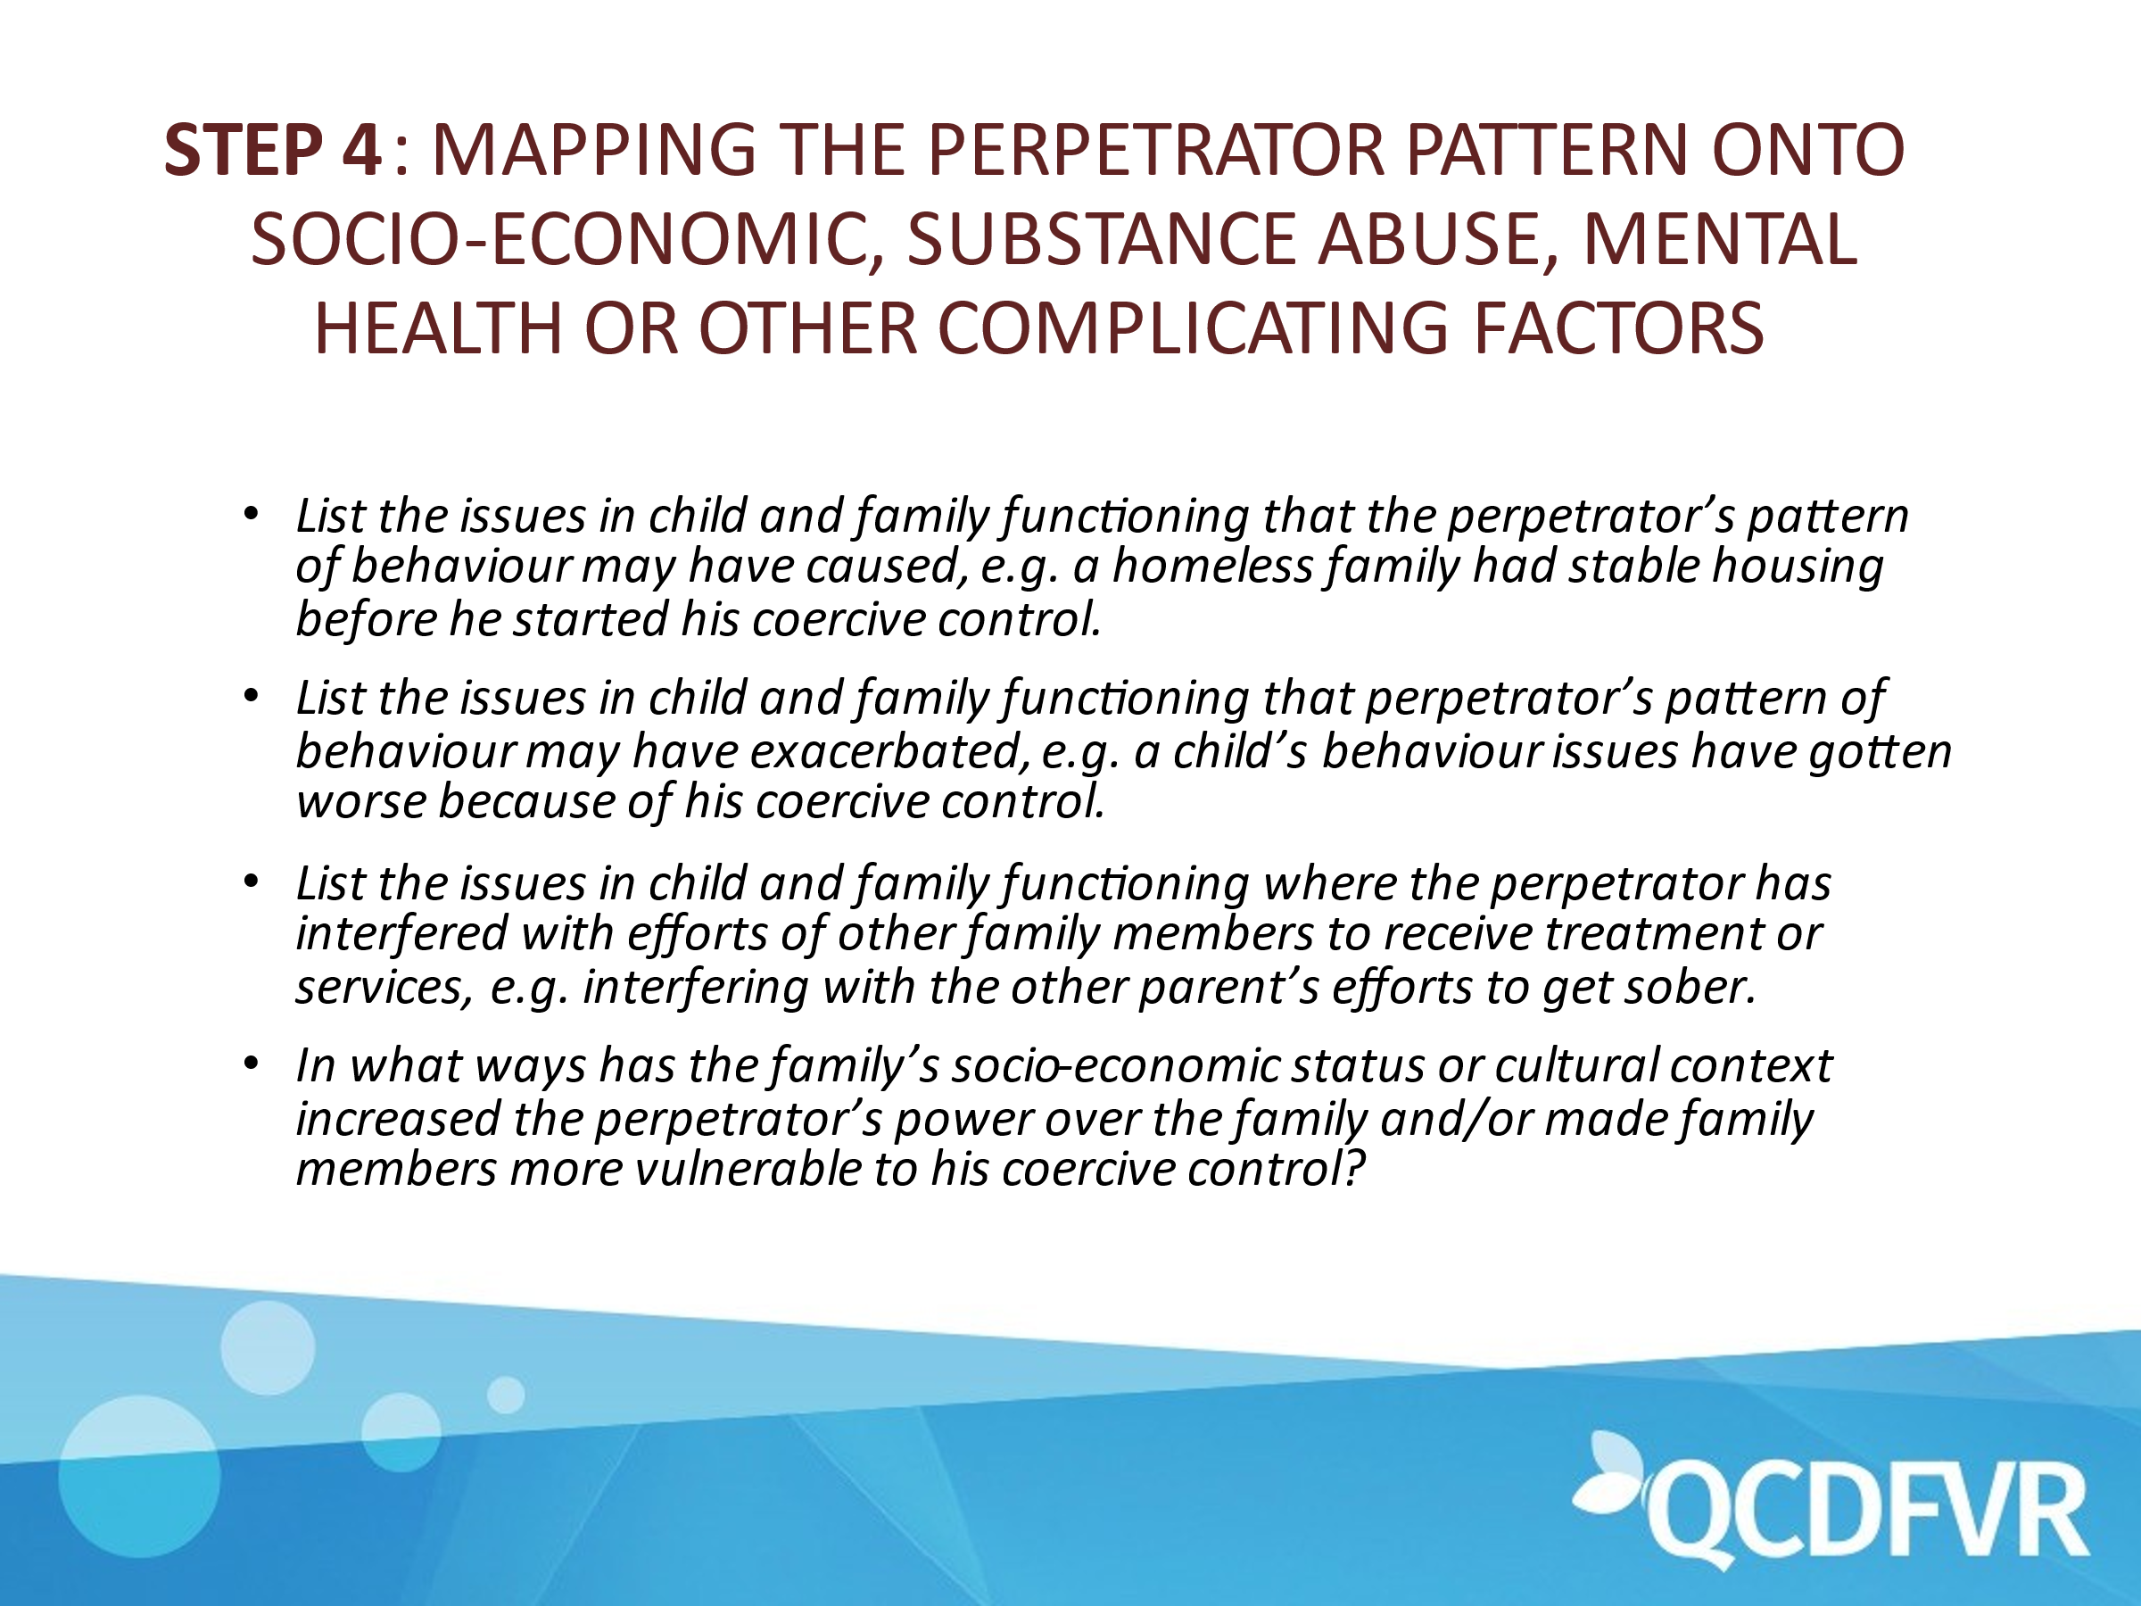

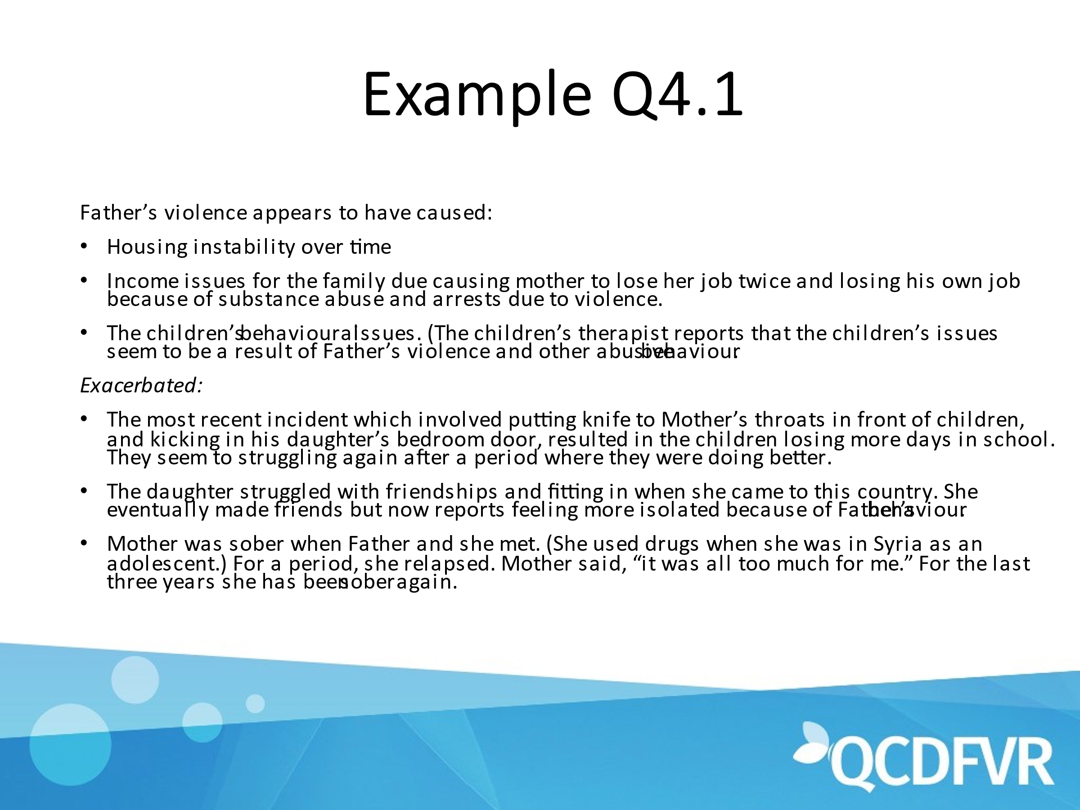

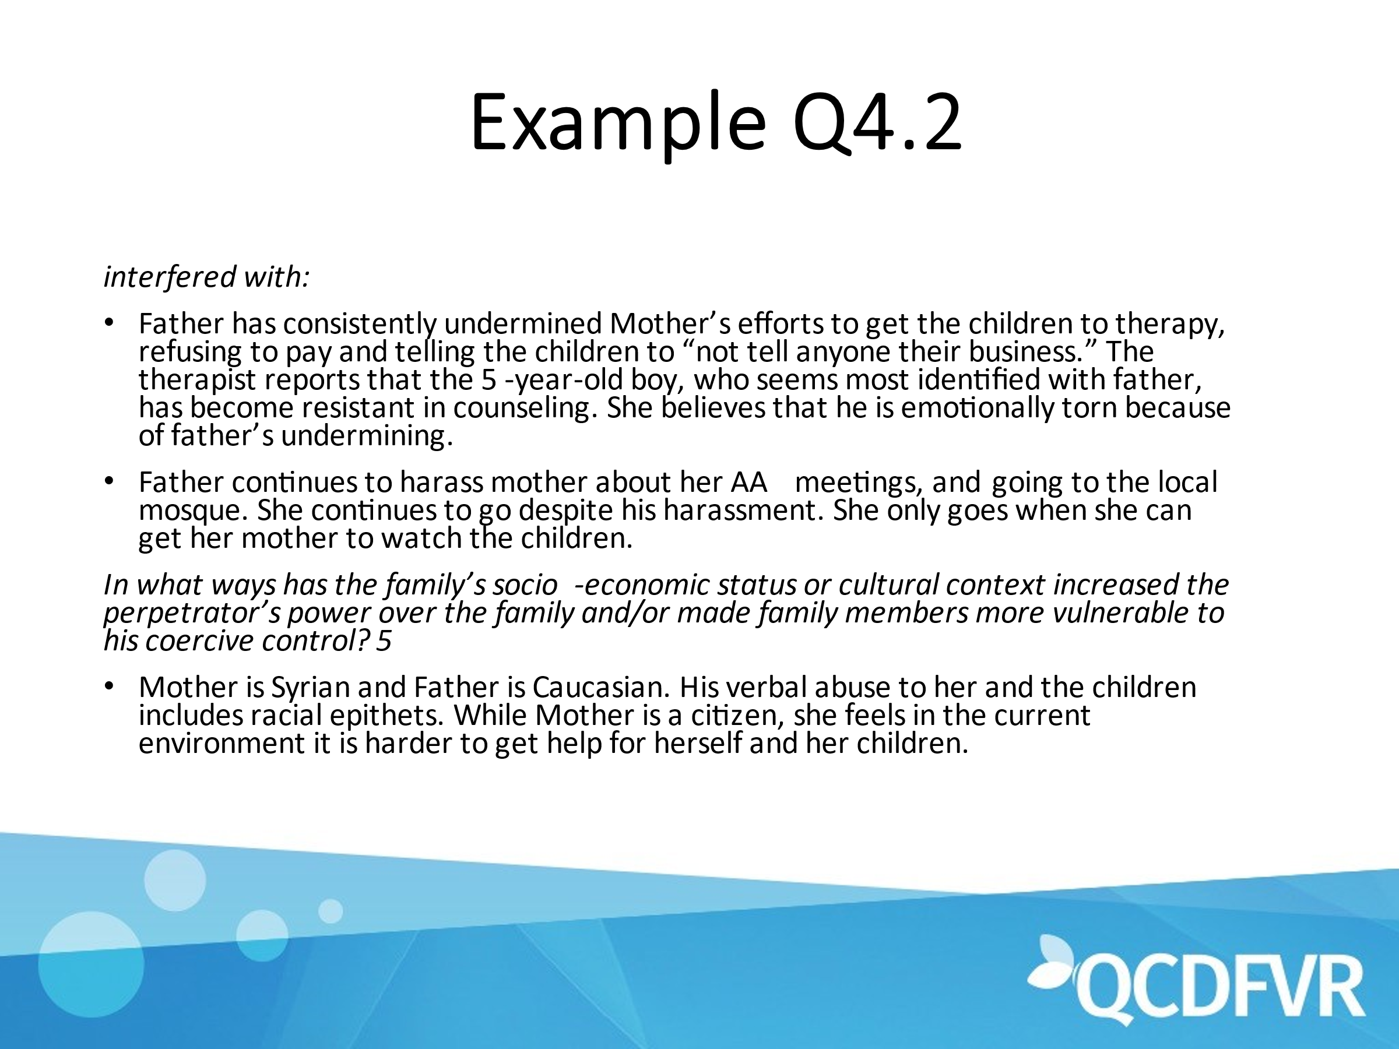

The final step involves reflection on the practice.

