

**Community of Practice:** **Peer Support, Sep 21**

**DFV Specialists within FACC and IFS**

Women’s Health and Wellbeing Support Services

**Peer Support notes – 23rd Sept 2021**

**Attendance –** 19 participants

**Apologies – 7 declined invite and three more gave apologies for not being able to attend.**

**Topic for discussion** – What does it mean to work in a preventative space for DFV?

***\*\*\*During this presentation a number of participants reported that they were feeling significantly overwhelmed at the moment. Participants reported that they were seeing a large number of clients who are very complex and high risk. There was discussion as well of how this complexity and increase in workload was taking a toll. A number of participants mentioned that they were actually working with other colleagues or clients during the session. Another complicating factor were the full waiting list preventing workers getting clients into other programs***

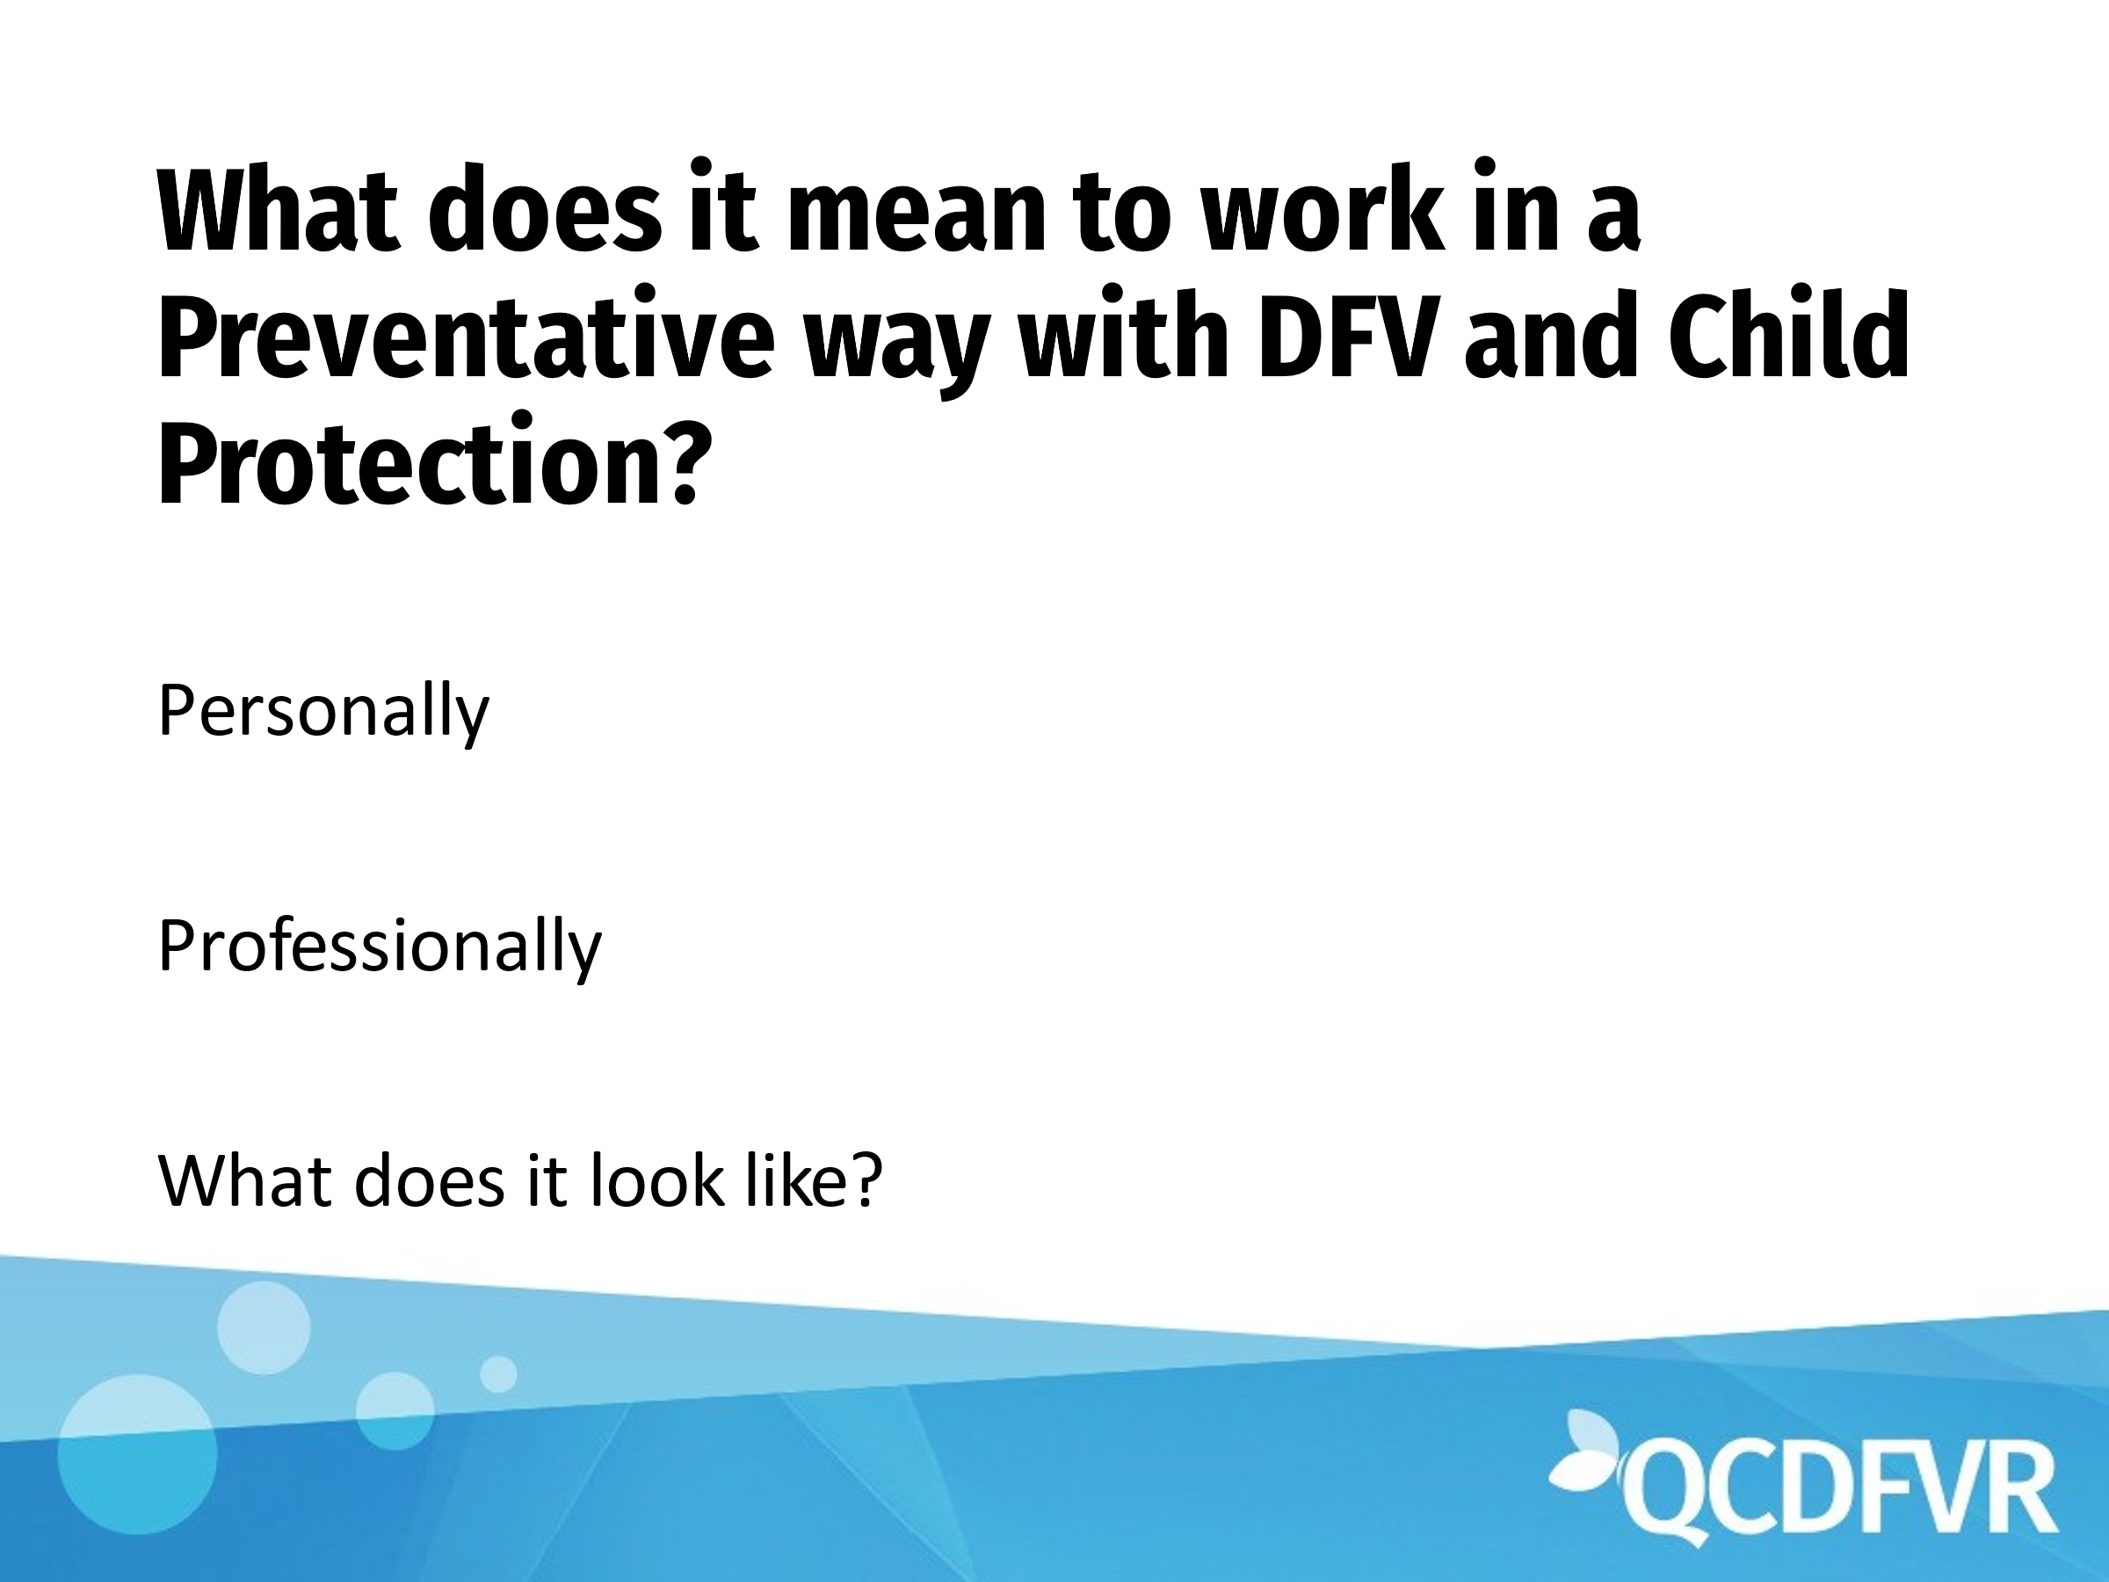

When workers were encouraged to suggest their understanding of preventative work, below are some of the comments:

* Preventative work is about her voice print, the impact that she has with all clients in what she talks about with them.
* the conversation needs to happen as this will help to reduce crisis in future I believe but it is hard to concentrate on it when crisis is right in front of you.
* I have recognized that the continuance of DFV being perpetrated is seeing families come back through with more complex supports required- sadly the services are overloaded with long waitlists and yes its putting pressure on staff.
* Everything we do has a preventative impact where we are aiming to break the cycle.

The national outcomes are:

1. Communities are safe and free from violence
2. Relationships are respectful
3. Indigenous communities are strengthened
4. Services meet the needs of women and their children experiencing violence
5. Justice responses are effective
6. Perpetrators stop their violence and are held to account.

Comments were made about the lack of measurables available with these outcomes. Unclear how we know we have achieved these goals.

Participants broke up into small groups and discussed what preventative work looks like for them as well as what they would like to do more of in order to help balance out the extreme end of response work.

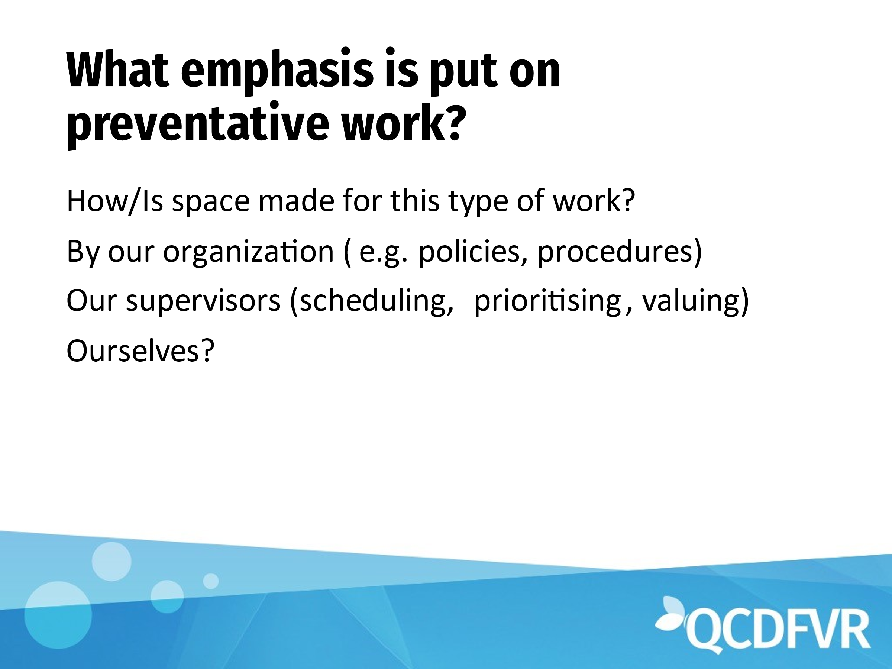

***A request was made for suggestions on external supervisors. Liz will follow this up with the group.***

Some suggestions were made.

* Rodney Vlais
* David Burck (Also known as Dave Banner) from YFS in Logan has previously offered external supervision. His field is within Adolescent to Parent violence and the Step by Step program that supports youth and their mothers.

