Feeling Safe at Home

Everyone deserves to feel safe at home. Violence is never okay!
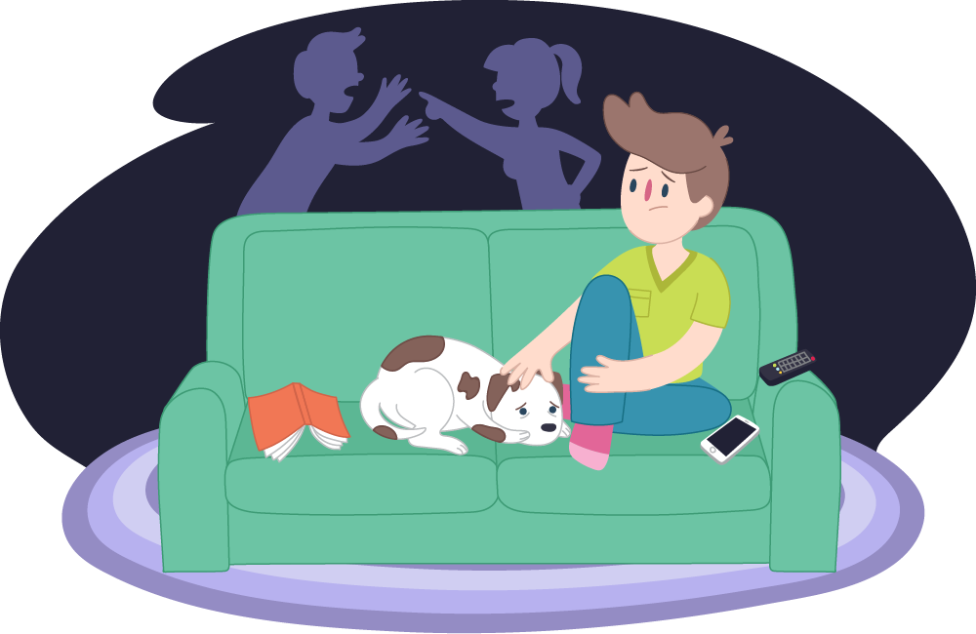

If an adult is violent, it is never your fault!
It is the adult who is being angry who is responsible.
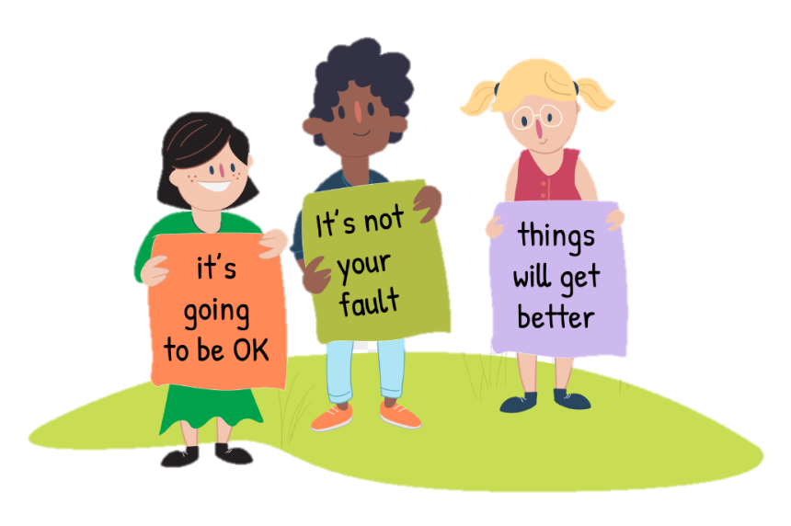
Violent behaviour at home is wrong, and there are always other ways to deal with problems.

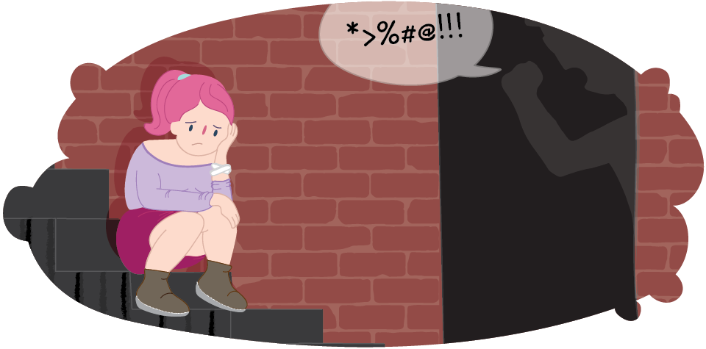

If an adult is violent at home, the kid’s job is to go to their safe place.
Do not get in the middle of the fighting.
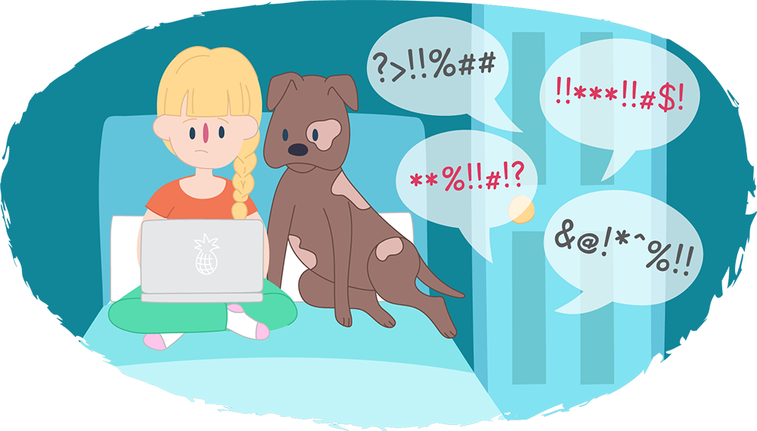
How would you know if you needed to go to your safe place?
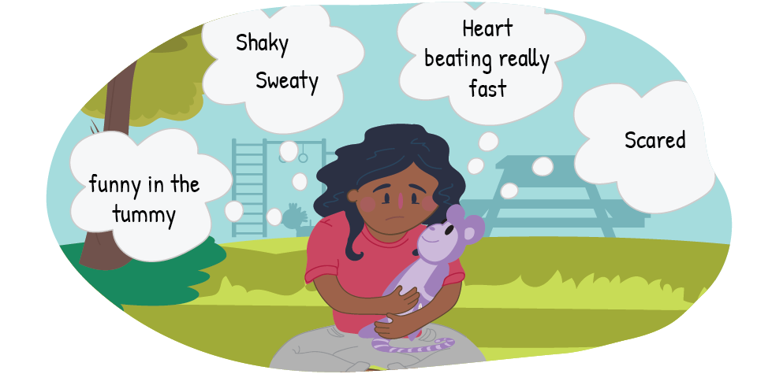

Where is your safe place at home?
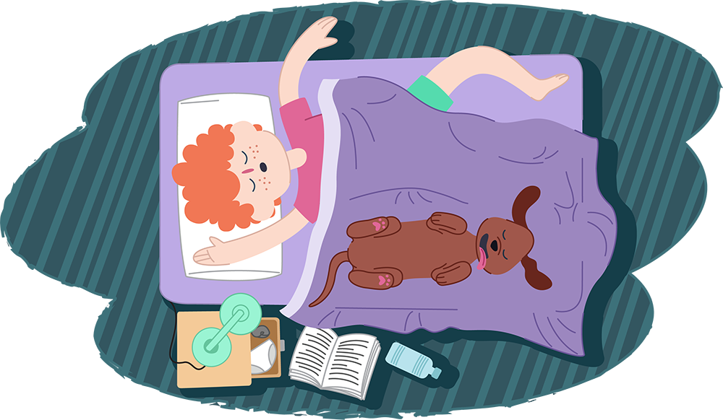
Sometimes, you might feel scared that the violence is going to seriously hurt someone in your home.
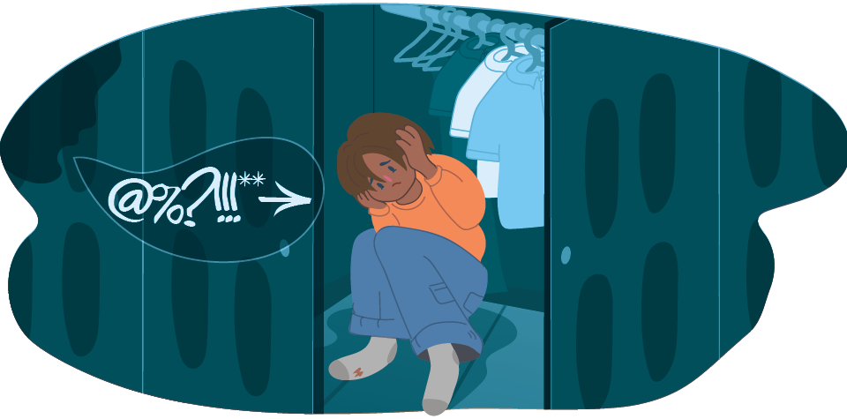

If you feel really scared, you are allowed to get help (neighbour, call the police, or call someone in your family).
Who could you go to for help?
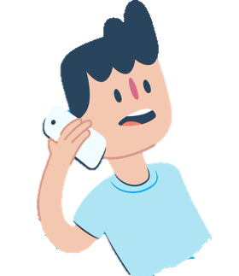
It’s always okay to talk about how you feel & get help from adults!
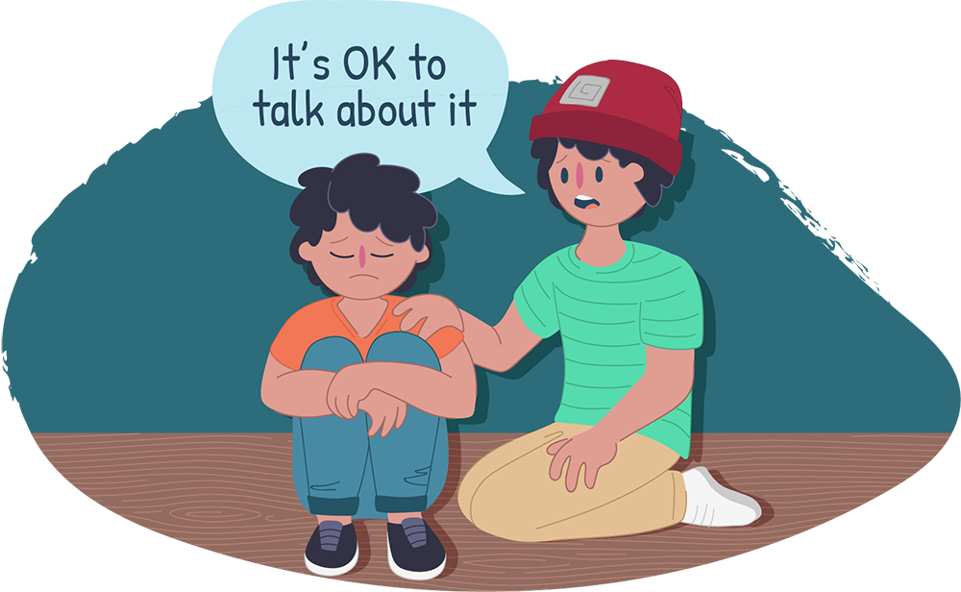

It’s an adult’s job to keep you safe.
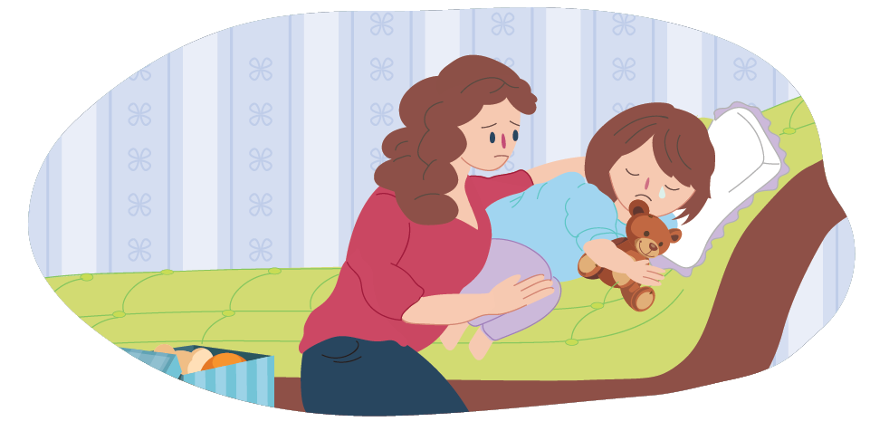

If there is violence at home, you might feel a mix of emotions.
Who can you talk to about your feelings?
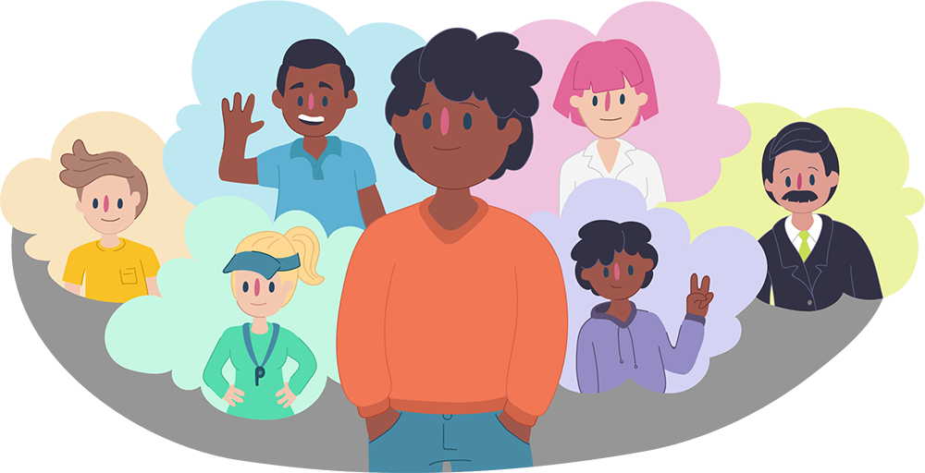

Do you have any questions?

