Feelings Worksheet
Step 1. If someone was feeling SAFE…
1. How might they think, feel 2. Who might be around?
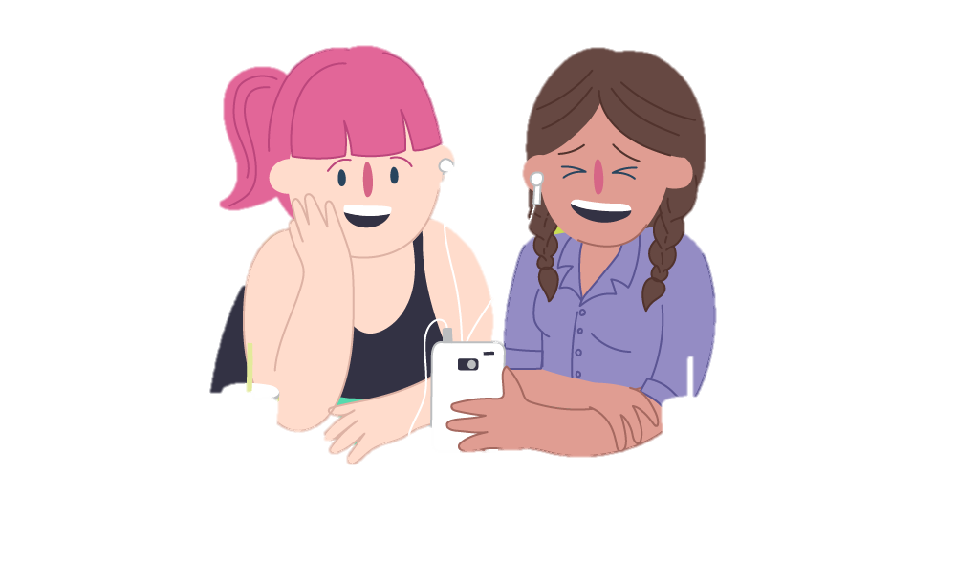
or behave?

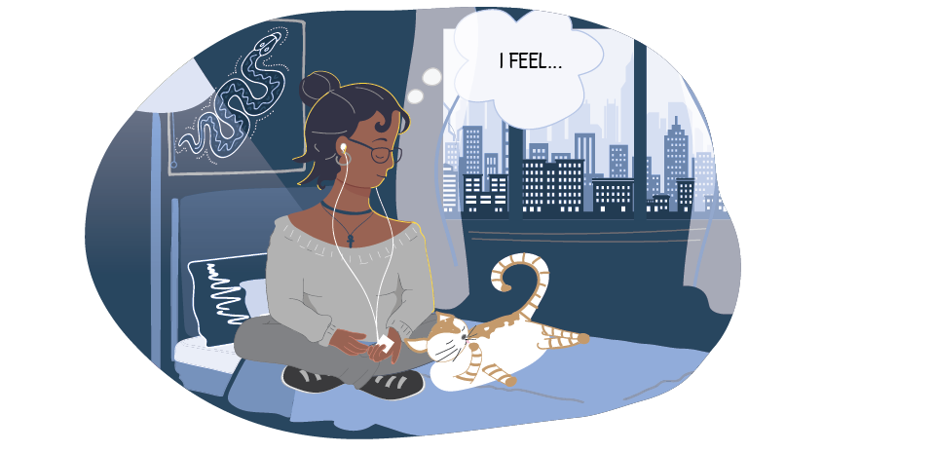
3. What might be happening 4. Where might they be?
in their body?

Step 2. If someone was feeling UNSAFE…
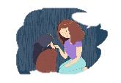
1. How might they think, feel 2. Who might be around?
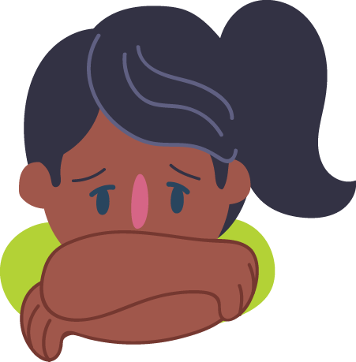
or behave?

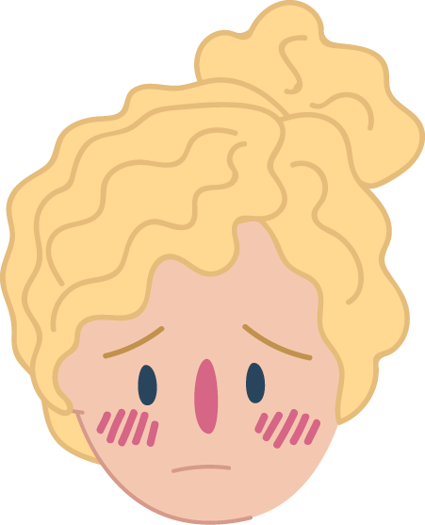

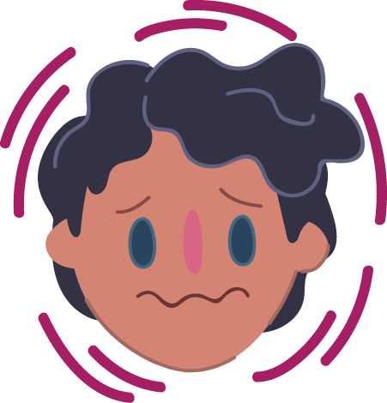
3. What might be happening 4. Where might they be?
in their body?

Step 3. If you were feeling UNSAFE…

- Draw your hand. Write 5 names you could tell? 2. Where are safe places to stay?

- What can you do to feel better?

Remember, everyone deserves to feel safe and listened to.

