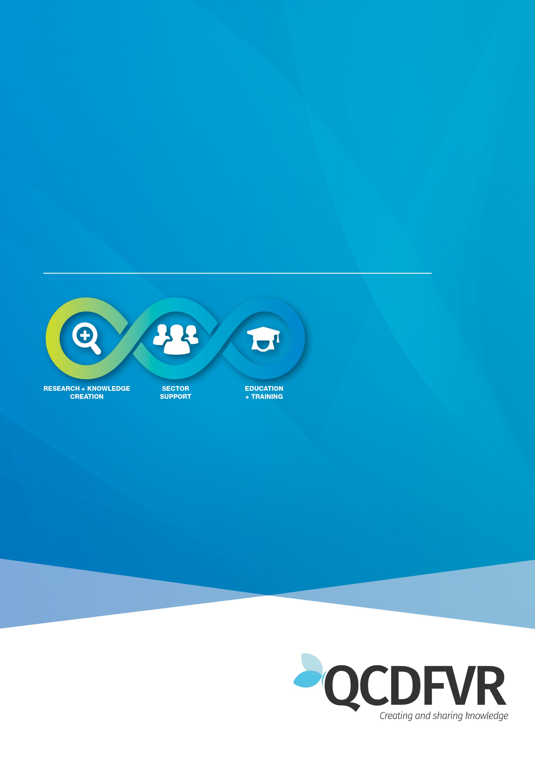

**Community of Practice:** **Peer Support: FEB 21**

**DFV Specialists within FACC and IFS**

Women’s Health and Wellbeing Support Services

**Peer Support notes – 18th February 2021**

**Attendance – 17 participants**

**Topic for discussion** – Safety Plans for children and Young People

*Unfortunately, this session was not recorded and therefore notes are minimal.*

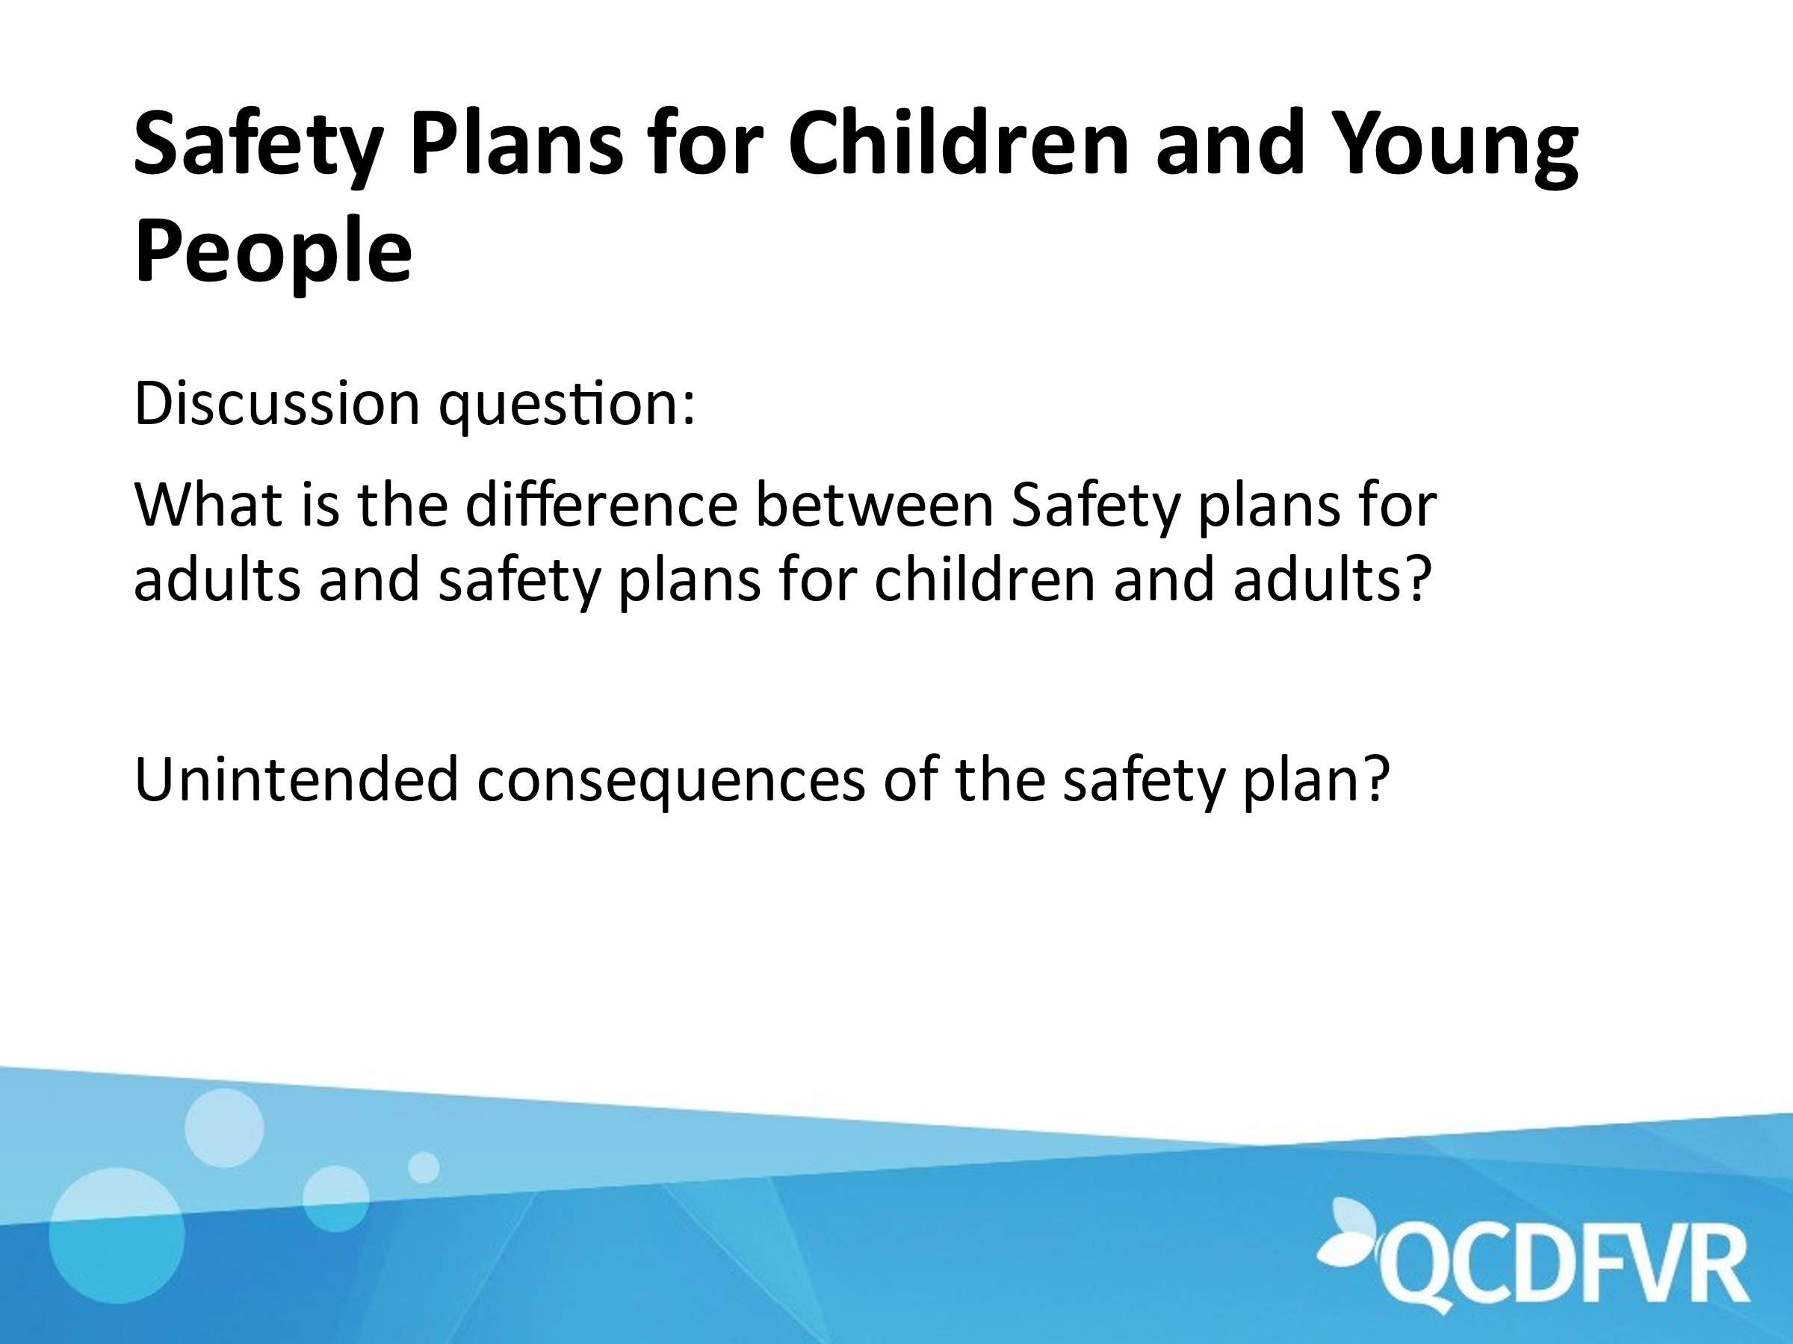

Participants were broken up into small groups and asked to discuss the above question. Some of the feedback from the breakout rooms was:

* The use of S and T tools
* Discussion with young people around “what is safety?”
* How do we approach safety with a child when the perpetrator is still in the house?
* Discussion around who is responsible for the child being safe?
* Safety planning for contact post separation can be very important.
* School often have safety plans around “emergencies” and it was suggested that language could be aligned to minimise confusion for children.
* Discussion about gaining consent from parents when doing any work with children and young people.
* A variety of resources were suggested for working with children and young people.

Participants were encouraged to share their favoured resources for working with children and young people and these would be compiled on the members site.

