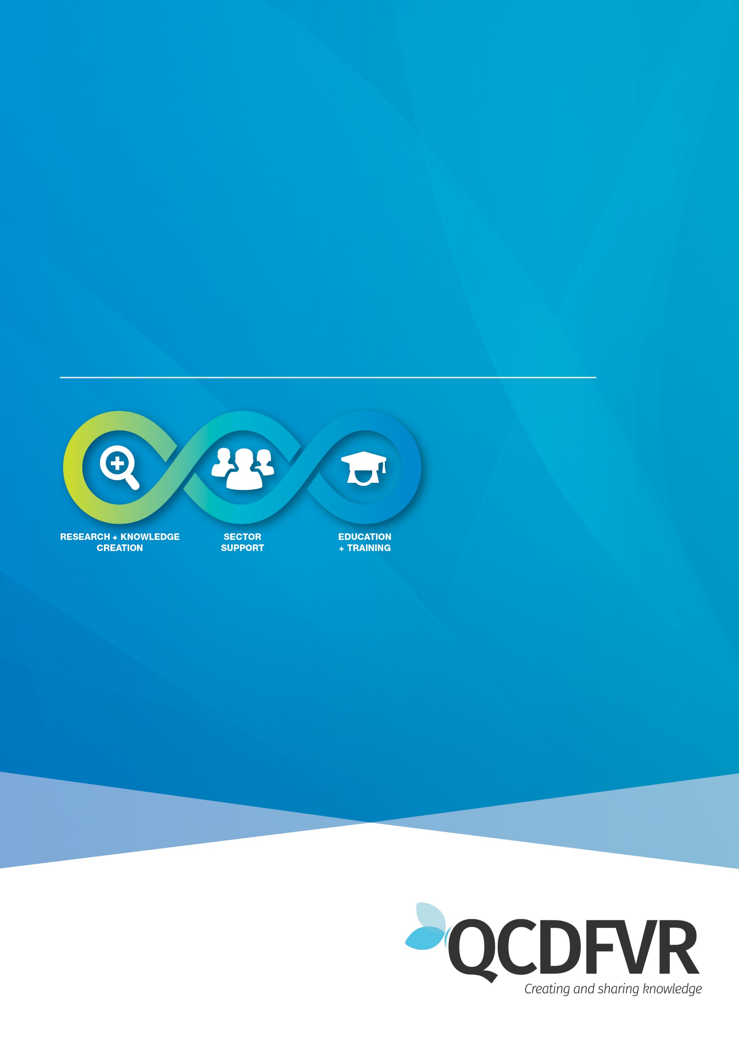

**Community of Practice** **Peer Support: 3/12/20**

**DFV Specialists within FACC and IFS**

Women’s Health and Wellbeing Support Services

**Peer Support notes - 3rd December 2020**

**Attendance -** 22 participants

**Topic for discussion** – Working with Young People and Partnering with non-abusive Parents

3 Questions were posed, and participants were broken up into small groups (breakout rooms) to discuss and then report back to the whole group.

1. **How do we work with young people?**
2. **What tools do we use?**
3. **What are the challenges when working with young people?**

*Where does the contact take place?*

* School
* Park
* Home
* Driving with adolescents
* Playing outside (e.g. soccer)
* Office
* McDonalds

*Challenges in working with young people in this space?*

* Building Trust, especially in short time span.
* Past negative experiences
* Children may not be home when the visit happens
* Contact is short term (FACC)
* Building trust can be tricky and take time.
* Adolescent to parent violence (APV)
* Adolescents peer group if they are not positive.
* Children being groomed by parents (either)
* Adolescents who have left the care system – important to leave the door open for future support.
* How do we best respond to disclosures to avoid blame?
* Drug and alcohol use – who to refer to?
* Parents hovering during conversation with young person/child.
* Systems that don’t prioritise safety of the child (e.g. Family Law Court)

*Tools and tips?*

* The Three Houses activity page 19 of WA’s Child protection paper on Signs of Safety. <https://www.dcp.wa.gov.au/Resources/Documents/Policies%20and%20Frameworks/SignsOfSafetyFramework2011.pdf>
* Finding a buy in from the child
* Providing options (flexibility) about the contact
* Safe and together model – Hold the child as centre of every conversation.
* WAVE model – critical thinking model
* Three-Legged Stool model
* Finding something that to connect with them on their level
* Good engagement and rapport skills
* Follow up and being consistent (rapport and trust)
* Elephant in the room book: <https://www.bookdepository.com/Elephant-Room-Leslie-Ponciano/9781492793243?ref=grid-view&qid=1607475755117&sr=1-1>
* Interview child/young person separately
* [www.lighthouseresources.com.au](http://www.lighthouseresources.com.au)
* Speak with them, not at them.
* Be authentic, be ourselves.
* Side by side work instead of face to face.
* Playing games

Discussion around some struggles with NDIS. Limitations and unintended consequences when keeping safe on NDIS, further traumatising and limiting support. Also, frustrations with trauma impacted children not qualifying for NDIS support. Alternatively, those with NDIS plans subsequently not qualifying for other packages or funding.

Housing struggles continue to escalate for victims of DFV.

Changes to Covid-19 legislation amendments (especially housing).

