**Community of Practice – Peer Support 7/10/2020**

**Notes from Discussion -** 12 participants

Topic for discussion – Attachment and Parenting

Brief overview of Attachment theory

**Caveat** Attachment theory can often be used to place blame on mothers. The original theory has been around for a number of years and is not really in line with contemporary family life.

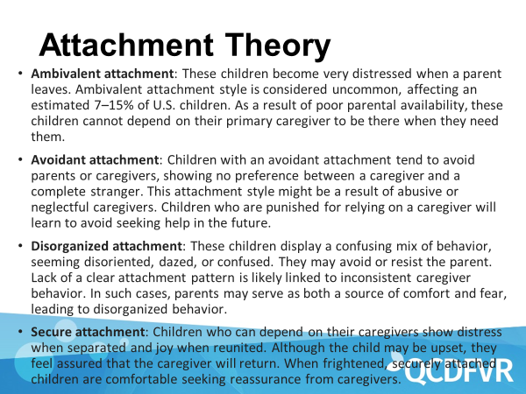

Then a discussion was had around how IPV interferes with attachment.

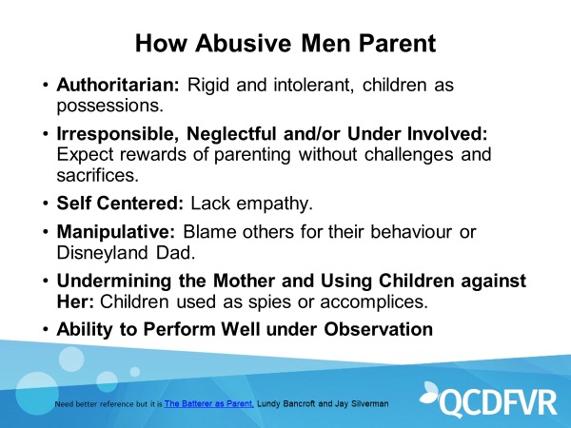

Discussion around how this occurs: Perp’s authoritarian behaviour could push mum to be more permissive, Perp’s permissive parenting can push mum to be more authoritarian.

Question posed to the group – Is it possible for the child to have a secure attachment when living in a home with IPV?

* It is limited
* It may not be consistent. But children in order to survive in this situation adapt to not having a secure attachment.
* Children are able to get secure attachment from other attachment figures (teachers, extended family).
* A stable and consistent mother can build a secure attachment
* Depends on context and supports available.

How do we talk about attachment and parenting in our work? Are parenting groups pushed to families that we work with?

* We can often approach our work as an attachment figure.
* All learning is good learning
* A change has been noticed by some in Child Protection space towards holding high parenting standards for fathers. (Safe and Together Model impact)
* Covid 19 had impact on availability of parenting groups.
* Still seeing discrepancy in responsibility of children towards mothers – lag of distribution of emotional labour.
* Concerns about referrals to parenting programs being another entity focusing on mother as ‘the problem’.

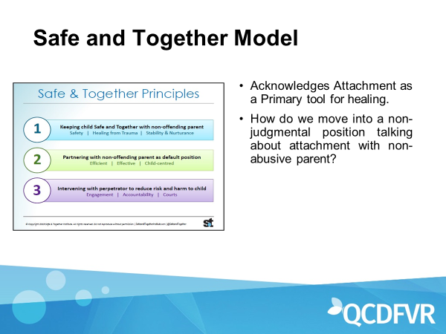

The impact of Safe and Together:

* Some reports that Child protection are focusing on strengths of non-offending parent.
* Other sectors (e.g. schools, health etc) need training to partner with mum.
* Still significant barriers to engaging with fathers.
* Perpetrators Mapping tool has been helpful in reflecting his behaviours and how it impacts on the children and her parenting.
* More focus on mums strengths.
* Still some Child Protection workers not identifying manipulation and colluding with perpetrators.

**Trends**

Increase in people moving to QLD from Southern states – concerns about what impact this has on service delivery in the future.

Increase in referrals from police, requiring assistance in parenting. Real struggles in delivering support.

With Child Safety being overwhelmed with Referrals (due to Covid 19), FACC and IFS are not working well to reduce numbers for Child Safety – unprecedented situation.

Talking Families website was discussed as a support for parents: <https://www.talkingfamilies.qld.gov.au/>