Community of Practice – Peer Support 16/7/2020
Notes from Discussion
22 participants

Topic for discussion – Vicarious Trauma and Self Care
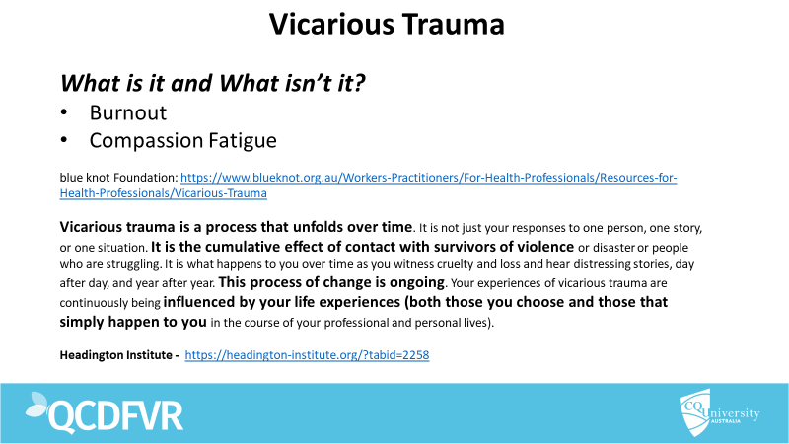

Literature states that there is a difference between Vicarious Trauma (VT) and Burnout or Compassion Fatigue.
Small group discussion about the difference of definitions.
- Informal debriefing with peers is very important
- Sense of humour is also important
- External factors (personal life) will impact on our individual capacity to deal with VT – being mindful of the impact of these factors.
- Burnout and Compassion fatigue can be a compounding factor to vicarious trauma.
- Hyper vigilance in our external lives.
- Sometimes we need to choose who we spend time with outside of our work – some people “get it” and some do not – the energy used to deal with people who don’t ‘know’ about DFV.
Discussion around limits to working in the sector:
- Passion and political motivation (social justice) are ways to keep us ‘in the work’.
- Strong mentors can make a huge difference in supporting us.
- When we see the signs that the work is taking a toll, workers spoke about concern in it affecting the quality of their work and ability to continue working.
- Reflective practice and self-awareness are critical
- Many practitioners have left the sector and re-engaged in the sector.
- Sometimes being on the ‘front line’ in crisis continually can be overwhelming and so a side-step can be a way to invest in longevity.
- Sometimes work mandated self-care days are not appropriate for all. Some practitioners have very robust self-care practices.
- Participants mentioned that VT can creep up on you.
- Being vulnerable and transparent in a confidential space with colleagues is critical. This allows self-awareness and understanding limitations.
- Creating boundaries can be challenging as awareness of DFV and child protection transfers into our personal life – “once you know, you can’t unknow’.
- Supervision is critical – Having a great manager goes a long way to preventing and identifying VT.
Discussion around self-care and supervision – how do we manage VT?
- Self-care days in an organisation can be challenging as it might not be everyone’s cup of tea. Management need to be aware of this and also be flexible.
- Staff having a safety and self-care plan – everyone is Accountable for each other.
Drowning in Empathy TED talk https://www.youtube.com/watch?v=ZsaorjIo1Yc
Self-entitlement - Justification as negative maladaptive behaviours because of the positive things you do.
Question posed about our potential maladaptive beliefs and behaviours eg: I can handle it.

Further thoughts for discussion: Is VT an occupational hazard?

