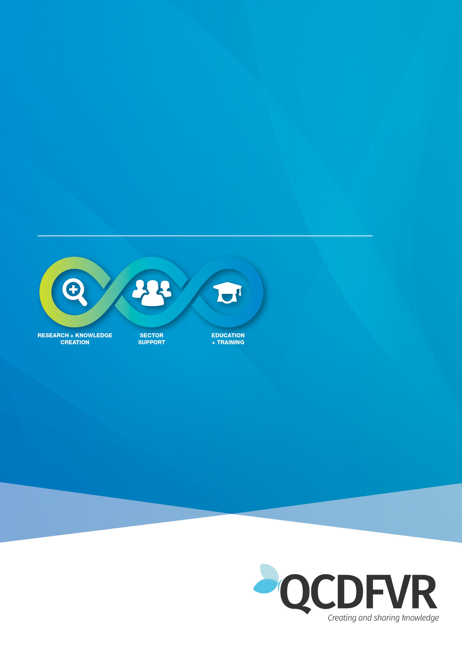

**Practice Paper May 2020  
PPRa**

**Domestic and family violence and its relationship to child protection**

# **Contents**

Introduction 1

Domestic and Family Violence 1

Legislation and Principles 4

Forms of Violence and Coercion 5

Perpetrators of Domestic and Family Violence 8

Characteristics of perpetrators 9

How Domestic and Family Violence Impacts on Women 10

Pregnancy and Early Motherhood 12

How Domestic and Family Violence Impacts on Children 13

Lethality Risk Factors 16

Safe and Together Model 17

Contact and Placement Decisions 19

Priority Populations 21

Rural and Remote Communities 21

Aboriginal and Torres Strait Islander Communities 22

Culturally and Linguistically Diverse Communities (CALD) 24

Women who Experience Disability 25

Resources 26

References 28

*This publication is correct as at May 2020. If hyperlinks contained in this document are not active, please email the Queensland Domestic and Family Violence Research Centre* [*cdfvrresearch@cqu.edu.au*](mailto:cdfvrresearch@cqu.edu.au) *with subject line: Child Safety Practice Paper.*

# **Introduction**

Domestic and family violence is a significant social problem which has become the focus of increased community concern. Whether children experience violence themselves or witness this behaviour, this violence can have long-lasting impacts on children’s wellbeing and development. The seriousness and prevalence of domestic and family violence mean that practitioners need ways to minimise risk to children and adult victim/survivors and to support their safety and wellbeing. In Queensland practice is guided by the Safe and Together model (Mandel, D 2017) and is underpinned by the Strengthening Families: Protecting Children Framework for Practice.

# **Domestic and Family Violence**

Domestic and family violence impacts upon the fundamental human rights of children and families to live in safety and security. Domestic and family violence is characterised by patterns of abusive behaviour in an intimate relationship or other type of family relationship where one person assumes a position of power over another and causes fear. It is also known as domestic violence, family violence or intimate partner violence (National Sexual Assault and Domestic Family Violence Counselling Service, 2015).

Queensland’s Domestic and Family Violence Prevention Strategy 2016-2026 (Queensland Government, 2016a, p. 1), identifies domestic and family violence as “any behaviour that is physically, sexually, emotionally, psychologically, economically, spiritually and culturally abusive, threatening, coercive or aimed at controlling or dominating another person through fear”.

It is the leading cause of death and injury in women under 45, with at least one woman in Australia murdered by her current or former partner each week (Australian Bureau of Statistics, 2013; Malone & Phillips, 2014).

Domestic and family violence is predominantly perpetrated by men against women and their children. In Australian and international studies of men and women who engage in abusive behaviour, the nature and consequences of women’s violence are not equivalent to that used by men. These studies indicate that men’s violence towards women is more severe as men generally possess greater strength and aggression. Consequently, the impact tends to be more significant for women and can include broken bones, loss of consciousness, injuries to sexual organs, head injuries, lacerations and bruising or death (Australia’s National Research Organisation for Women’s Safety, 2016).

Perpetrators of domestic and family violence are most often men, while victims are most often women (Garcia-Moreno, Guedes, & Knerr, 2012). Women in Australia are most likely to experience violence from current or former partners (Australia’s National Research Organisation For Women’s Safety, 2016).

Recent research suggests that as many three in ten women have experienced physical violence since the age of 15, whilst one in six women have experienced violence by an intimate partner (ABS, 2017). These numbers are even higher for women who identify as Aboriginal or Torres Strait Islander. It is estimated that half of the Aboriginal and Torres Strait Islander women in Australia experience domestic and family violence (Department for Child Protection, 2013). Child witnesses of violence are most likely to be in families where the perpetrator is their father and the protective parent is their mother (Hooker, Kaspiew, & Taft, 2016).

The perception that women are also commonly perpetrators is not generated from statistics or supported by practitioners working in the field. This is not to say that some men, sometimes, experience violence from their female partner, however, the reality is that relatively few men in heterosexual relationships are solely victims of intimate partner violence. Men are much more likely than their female partner to be using a number of repeated forms of violence to dominate and control (White Ribbon Australia, 2017). Men’s violence is more likely to inflict severe injury and to result from attempts to control, coerce, intimidate and dominate women partners (Australian Bureau of Statistics, 2013). Where violence is used by both partners in a relationship, the woman’s acts are more likely to be in self-defence (Garcia-Moreno et al., 2012).

The term ‘domestic and family violence’ (DFV) is used throughout this paper as it is defined within Queensland legislation. The term ‘victim’ is used inclusively, relating to the non-violent partner, children and other family members who experience and are impacted by the violence and abuse. This paper uses language that represents the most common perpetrator of violence A screenshot of a cell phone
– that is men being violent towards women.

# **Legislation and Principles**

It is important for practitioners to be aware of legislation pertaining to domestic and family violence and the intersection with their work. The key principle under The Domestic and Family Violence Protection Act 2012 (Qld) is that the safety, protection and wellbeing of people who fear or experience domestic violence, including children, are paramount. Recent amendments to the Act (Domestic and Family Violence Protection and Other Legislation Amendment Bill 2016 [Qld]) are aimed at improving responses by:

* introducing a framework which enables key government and non-government entities to share information for the purpose of assessing risk and responding to serious domestic violence threats;
* expanding the protection that police officers can provide to victims prior to the court deciding whether to make a domestic violence order (DVO);
* requiring the court to focus on the protection needed by a victim in determining the appropriate duration of a protection order;
* requiring the court to consider any existing family law parenting order it is aware of and whether that order needs to be varied or suspended if it is inconsistent with the protection needed by the victim or their children; and
* increasing maximum penalties for breaches of police protection notices and release conditions to achieve consistency with the penalty for breaching a DVO.

The role of the child safety practitioner in relation to legal matters and courts has moved beyond that of removal of children to also considering how children and their mother can be protected in the court system when domestic and family violence is a factor. The need for protection will be established when patterns of abusive behaviour are mapped after talking to the mother, father and child about what is happening (using the Safe and Together model outlined later in the paper). Changes to family law parenting orders or applying for a domestic violence protection order to protect the mother and the child may be required in order to protect both the adult victim and the child victim. Specialist domestic and family violence workers in Family and Child Connect, Intensive Family Support services or specialist domestic and family violence services can provide support to the mother or practitioner in relation to domestic violence protection orders.

The amendments to the Domestic and Family Violence Protection Act 2012 mean that practitioners who are prescribed entities have increased capacity under Part 5A of the Act to share information appropriately, including without consent, in order to assess and manage domestic and family violence risk. Domestic and Family Violence Information Sharing Guidelines (Queensland Government, 2017b) provide principles and information for information sharing without consent and should be referred to. This document is available online.

Further readings:

[Queensland Legislation](https://www.legislation.qld.gov.au/view/pdf/asmade/act-2012-005)

[Legislation explained - The Domestic and Family Violence Protection Act 2012](http://www.domesticviolence.com.au/files/pdf/Legislation-Explained-The-Domestic-Violence-Family-Protection-Act-2012.pdf)

# **Forms of Violence and Coercion**

Effective assessment and intervention rely upon an understanding of the range of behaviours which constitute domestic and family violence. Verbal, social and emotional abuse are not as readily observable as the behaviours or consequences of physical abuse and can be overlooked as being less severe or as not having the degree of impact compared with physical or sexual abuse – this is not the case. In the following table examples of violence and coercion are provided, but this list is not exhaustive.

|  |  |
| --- | --- |
| **Form of violence** | **Examples of violence** |
| **Emotional and verbal violence** | * words or phrases used to humiliate, degrade, demean, embarrass or intimidate * harassment at the victim’s workplace * threatening to remove the victim’s children using systems’ such as family court or notifying Child Safety * threatening to harm pets, property or possessions * threatening to suicide if the relationship ends threatening to kill or harm the victim and/or children |
| **Physical violence** | * pushing, slapping, punching, kicking, strangling, choking, biting, shaking, inflicting burns, hair pulling * using a weapon such as a belt, knife or gun to harm the partner, children or pets |
| **Sexual violence** | * forcing a person to have sex or take part in sexual acts against their will * using an object or body part to penetrate the vagina, mouth or anus without consent * injuring sexual organs * forcing a person to have unsafe sex without protection against pregnancy or sexually transmitted infections * forcing someone to observe or take part in sexual activities, pornography, voyeurism or exhibitionism |
| **Social violence** | * behaviour that limits, controls or interferes with a person’s social activities or relationships with others * excessive questioning, stalking, monitoring movements and social communications including texts or social networking * social control and isolation to separate the victim from friends, family and community agencies limiting and controlling a person’s movements |
| **Financial violence** | * exercising control of all finances in order to increase the powerlessness and dependence of the victim * taking the victim’s money, or personal items such as keys and car * making a person ask for necessities * demanding that a person maintain a household on limited amounts of housekeeping money and then abusing them for not being able to do so. |
| **Spiritual and cultural violence** | * denying the victim access to cultural land, sites or family * denying the victim’s access to cultural or spiritual ceremonies or rites * preventing religious observances or practices * forcing religious ways and practices against the victim’s own beliefs * undermining the person’s cultural background, particularly for people from culturally and linguistically diverse backgrounds * threatening deportation, or to withdraw support for applications made through the Department of Immigration and Multicultural Affairs |

To learn more about different forms of violence and how it is taking place, e.g. technology abuse, please press [here.](https://familyviolencelaw.gov.au/domestic-family-violence/what-is-domestic-and-family-violence/),

**Reflection**

The Duluth Power and Control Wheel (2017) illustrates a variety of tactics used to create coercive control over an intimate partner. A knowledge of the tactics and patterns of harm is important in working with families You can learn more about this at the following link – <https://www.theduluthmodel.org/wheels/understanding-power-control-wheel/>

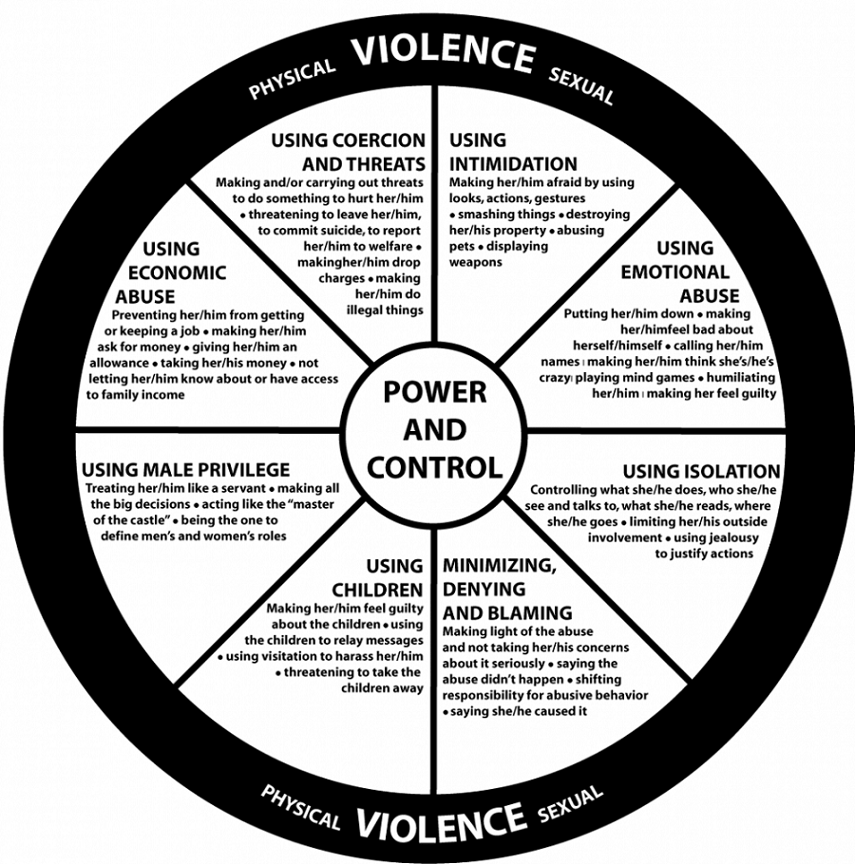

Duluth Power & Control Wheel (DAIP, 202 East Superior St, Duluth, Minnesota55802. [www.duluth-model.org](http://www.duluth-model.org)

# **Perpetrators of Domestic and Family Violence**

Researchers studying perpetrators of domestic and family violence have highlighted the diversity of men who commit violence against women. Contrary to some beliefs, perpetrators are found in all social classes and engage in a variety of lifestyles, social roles and cultural practices. Perpetrators may appear to be presentable and responsible people, exhibiting strength, dependability and self- control. At the same time, within the family home, they may control family members through superior physical strength, threats and fear.

## **Characteristics of perpetrators**

There are many societal myths associated with perpetrators. For example, perpetrators may be described as ‘mentally ill’, ‘unable to control their anger’, or are ‘abusive only when drunk’. Perpetrating violence is a choice, although typically it is not seen as such in the mind of the perpetrator. What is known is

* abusive behaviour can be chronic, although rarely disclosed as such.
* unlike in random violence, victims have ongoing relationships with the perpetrator.
* perpetrators are likely to have continuing access to victims, knowing where they work, where extended family live and having access to the family when having contact with children. There are multiple opportunities for intimidation, threats and psychological pressure, whether or not the parties are separated. Separation, in fact, represents a time of increased risk for abuse to occur.
* there are a high proportion of perpetrators who use alcohol and / or illicit drugs. Although intoxication due to alcohol or drug use does not cause violence, abusive men are prone to become more severely, and more frequently, violent while under the influence.
* perpetrators are often convinced they are victims. Perpetrators of domestic and family violence are particularly insistent about their victimisation. Historically they were protected by traditions of privacy, and beliefs about keeping family matters within the family.
* perpetrators may try to ‘divide and conquer’ running a disinformation campaign and trying to get others to side with them.
* they may look for divisions between people and exploit them, and tell different versions of the facts to different people. This manipulation can include using agencies and departments to suit their own needs.
* perpetrators may continue to deny or minimize the abusive behaviour and blame their partner, taking a long time to admit responsibility for their behaviour – if ever.
* perpetrators may attempt to get those working with them to engage less by being constantly angry and challenging. They may present as ‘justifiably angry’, saying their partners are crazy, and being accusatory towards others. Faced with constant “righteous” anger, it may be easier for the practitioner to shift the discussion toward less volatile ground such as the partner’s parenting (Department for Child Protection, 2013).

Perpetrators may further harm children physically, sexually, emotionally, and through neglect. Harm may occur because:

* they may focus their attention on controlling their partner rather than engaging as a parent or prevent their partner from caring for their children resulting in neglect of the children.
* they may prevent their partner from seeking medical treatment for the children, particularly when they have physically abused them, heightening the risk of serious injury and even death in the case of babies and infants
* they may hurt children emotionally by verbally abusing them, or damaging their relationships through using them as a tool by coercing them into abusing the other parent
* they may hurt children emotionally by creating an environment in which children live with fear, even if they never see or hear violence or abuse occurring, and which may undermine the ability of practitioners and service providers to intervene and protect them.

# **How Domestic and Family Violence Impacts on Women**

The harms associated with domestic and family violence may be short-term or long lasting and may include:

* shame and embarrassment
* anxiety
* depression and other emotional distress
* suicide attempts
* alcohol and drug abuse
* eating disorders
* sleep disturbances
* reduced coping and problem solving skills
* reduced decision-making skills
* chronic disorganisation
* loss of self-esteem and confidence
* fear of starting new relationships
* acute and/or chronic fear
* learned helplessness, and
* loss of hope.

A common question is ‘why doesn’t she leave’? The answer is complex but common factors include victims fearing for their lives or that of their children if they leave following threats from their partner, as well as having little, or no, social support, money or access to alternative housing. There is the hope that the perpetrator may change their behaviour and often a reluctance to remove children from their home and concern about losing their children in a custody battle (Queensland Government, 2017a). Rarely is the question asked as to ‘why doesn’t he leave’ despite the fact that generally it is the male who is perpetrating domestic and family violence.

While many women go to great lengths to counteract the effect of abuse on their parenting, the harms identified above may impede their capacity to parent their child/ren effectively, especially if the perpetrator is using a variety of tactics to undermine the mother/child relationship. Such tactics can include, expecting women to control child/ren, demanding the complete attention of the woman at the expense of the child/ren and deliberate undermining in the presence of child/ren (Hooker et al., 2016, p. 89). These tactics can significantly alter the motherhood experience particularly in light of the lack of control in a violent environment, and potentially lead to disordered attachment between the mother and child/ren. Support for women with regard to mitigating or overcoming the harms and strengthening their parenting capacity and attachment between mother and child, will be needed.

It is easy for the focus to centre on the mother and her behaviour, particularly in relation to how protective she has or hasn’t been. However, when domestic and family violence is a presenting factor, the focus needs to ‘pivot’ to the perpetrator and his pattern of behaviour in order to fully understand, reduce risk and address safety concerns for the children and family. This focus of intervening with the perpetrator to reduce risk and partnering with the non-offending parent to keep children safe is critical for safety-oriented practice.

# **Pregnancy and Early Motherhood**

Research shows that domestic and family violence often begins when women are pregnant or have recently given birth. Where violence was previously occurring, it often escalates in frequency and severity during pregnancy and early motherhood (Clements, Holt, Hasson, & Fay-Hillier, 2011). Indigenous women, women aged between 18-24 years, and women with a disability are at a particularly significant risk of experiencing severe violence from their partners during pregnancy (Campo, 2015; Mitra, Manning, & Lu, 2012).

The principal cause of death to a mother during pregnancy is domestic and family violence-related homicide, both in Australia and globally (Clements et al., 2011; O'Reilly, 2007). Whilst abuse occurs before and after pregnancy, it has been observed to occur more frequently during the vulnerable time of pregnancy itself (Menezes Cooper, 2013; O'Reilly, 2007). Violence perpetrated against pregnant women can be particularly dangerous and has significant negative impacts on both the mother and unborn child, including increased mental and physical illness for the mother; and an increased risk that the foetus will be miscarried, or that there will be long-term effects on the child (Menezes Cooper, 2013). There is also evidence that assaults during this vulnerable time is ‘double intentioned violence’, where perpetrators may aim physical violence at their partner’s abdominal area, genitals and breasts, so that abuse is both of the mother and child (Campo, 2015; Humphreys, 2007).

Negative or volatile family dynamics, financial difficulties, low social support, substance abuse, and having multiple sexual partners are identified risk factors for experiencing domestic and family violence during pregnancy (McMahon & Armstrong, 2012). Although pregnancy and the postpartum period are especially vulnerable times for mothers and their infants to experience domestic and family violence, this period also represents an opportunity for health care professionals, particularly midwives and child health nurses, to assess and provide support to the mother. They may be the only service providers a pregnant victim comes into contact with who are able to assess for abuse and take actions towards resolving it (Menezes Cooper, 2013; Mitra et al., 2012). Routine screening for domestic and family violence in antenatal settings, for example by midwives, is highlighted in the 2015 Queensland Government Special Taskforce Not Now, Not Ever Report, as a promising pathway for early intervention. The prevalence of domestic and family violence and the severity of its impacts during pregnancy and early motherhood, suggests that there is an opportunity for early interventions, including referrals to DFV services, to be made by professionals working in perinatal, maternal, and child health services. As with all women, the best way to determine the support that a woman who is pregnant needs - is to ask her.

# **How Domestic and Family Violence Impacts on Children**

For children, the impacts of repeated abuse and exposure to domestic and family violence are profound and traumatic. Children do not become used to violence, they adapt. When there's violence in the home, children are always affected, even if they are asleep or not in the room when the violence occurs. The longer the children live in a violent situation, the more difficult it will be for them. When violence occurs, children may feel scared and ashamed, or they may even think that they caused the problem or may grow up perpetrating violence upon others.

“A child’s response to repeated domestic violence depends on a number of factors including their age, gender, personality and family role. Some of the immediate effects can include:

* Blaming themselves for the violence
* Experiencing sleeping difficulties, such as nightmares
* Regression to an earlier stage of development, such as thumb sucking and bedwetting
* Becoming increasingly anxious or fearful
* Displaying aggressive or destructive behaviour
* Starting to withdraw from people and events
* Becoming a victim or perpetrator of bullying
* Starting to show cruelty to animals
* Experiencing stress-related illnesses, such as headache or stomach pain
* Displaying speech difficulties, such as stuttering
* Misusing drugs and alcohol (in young adults).

What do children learn growing up in a home with domestic violence and what do they need?

* They learn that threats and violence get you what you want (and you won’t get in trouble), unequal relationships are normal, you must either be the victim or the perpetrator, the world is a dangerous place and no one can protect you.
* Children in homes with domestic violence need certain messages to help them recover from trauma. They need to know that the abuse is not their fault and that no one deserves to be abused, no matter what. They need help with getting and saying safe”

How are children affected by domestic violence? (2014) Retrieved form: <https://www.dvpc.org.au/information-about-domestic-violence-in-the-act/how-are-children-affected-%20by-domestic-violence/>

Children who are in this situation are required not only to manage the immediate consequences of the violence, they must also attempt to make sense of how a parent or family member can alternate between caring acts and violent acts. The effects of being in this situation may impact on the child’s emotional and physical wellbeing, their attachment with their protective parent and their development, including social, physical and psychological development (Morris, Humphreys, & Hegarty, 2015).

In recent years, the experiences of children and young people witnessing violence have been increasingly understood through the lens of complex trauma. Trauma is commonly understood as a distressing or life-threatening situation. Complex trauma is cumulative, repetitive and interpersonally generated. It differs from single incident trauma such as an earthquake, car crash or cyclone by the fact it not only reoccurs, but the trauma involves another human violating the safety of the child or young person. When that person is the father, mother, step-parent or extended family member, this creates a situation where the child must face each day prepared for that person to become unsafe.

**Reflection**

To have a clear understanding of how a child can be affected by exposure to domestic and family violence, it is important to be familiar with various developmental stages. Are you familiar with these? If not, this may be a helpful attachment for you.

Further readings:

[Domestic violence as a form of child abuse: Identification and prevention](https://aifs.gov.au/cfca/publications/domestic-violence-form-child-abuse-identification) [Exposure to psychological domestic abuse most damaging to children's wellbeing](https://www.sciencedaily.com/releases/2017/05/170515095442.htm)

[Effects of child abuse and neglect for children and adolescents](https://aifs.gov.au/cfca/publications/effects-child-abuse-and-neglect-children-and-adolescents)

[What is Trauma and Adversity?](https://emergingminds.com.au/resources/what-is-trauma-and-adversity/)

The impact of complex trauma can be far-reaching. Workers who come into contact with children who have experienced domestic and family violence may notice either an arousal state (includes hyper- vigilance and an increased startle reaction) or an avoidance state (numb or seemingly day-dreaming). Research over the past ten years has begun to pinpoint the impact of complex trauma on brain structure and chemistry (Malchiodi, 2015).

An understanding of the changes in the brain helps workers have insight into behaviours by children and young people that may otherwise be misunderstood as ‘defiant’, ‘naughty’, unmanageable’, ‘not paying attention’ or even ‘spaced-out’. Despite major impacts on children’s brain patterns, the brain is always changing and evolving according to what it is learning. The neuron pathways in the brain CAN be changed over time, through awareness, practice and patience.

Further readings:

[The Impact of Abuse and Neglect on the Developing Brain](http://teacher.scholastic.com/professional/bruceperry/abuse_neglect.htm) [Bruce Perry: Attachment and Developmental Trauma](http://attachmentdisorderhealing.com/developmental-trauma-2/)

# **Lethality Risk Factors**

There are a number of warning signs, red flags and indicators of harm that have been found to precede intimate partner homicides. Recognising the static and dynamic multiple risk factors that may be occurring is important in assessing and managing risk and the development of safety plans. Static factors include the history of the pattern of abuse. Dynamic risk factors are those that fluctuate and change, such as drug and alcohol use, highlighting the importance of monitoring risk and adopting interventions based on dynamic changes. Research indicates that the woman’s assessment of her level of risk is a critical indicator of her actual risk (Victorian Department of Human Services, 2012). This is because of her intimate knowledge of the perpetrator, his emotional state, the changes in the situation or his behaviour that increase danger to herself and her children. This is a good reminder of the importance of asking questions about a woman’s level of fear. If a woman (or child) say they are frightened, they should be believed, their fears taken seriously and safety planning undertaken (National Sexual Assault and Domestic Family Violence Counselling Service, 2015).

Risk factors include, but are not limited to:

* previous incidents of attempted choking or strangulation
* history of domestic violence
* escalation of intensity and frequency of the violence
* pregnancy
* separation or intent to separate
* access to weapons
* threats to kill adult victim and/or children or others close to the victim
* stalking
* intimate partner sexual violence and/or sexual jealousy
* coercive control (considering the cumulative effect of domination/subordination in the abusive relationship e.g. isolation)
* non-compliance with court order
* perpetrator self-harming, threatening or attempting suicide
* pet abuse, or threats of pet abuse

The period following separation is the time of highest risk of being killed or seriously injured.

# **Safe and Together Model**

The Safe and Together model (Mandel, 2017), uses a perpetrator pattern-based definition of domestic violence, which strengthens the ability of the practitioner to understand how the perpetrator is creating harm or the risk of harm to children. This is important as a perpetrator can be adept at ‘image-making’ creating a perception of the victim as the problem, crazy or difficult, particularly if the victim has used ‘violent resistance or reactionary use of violence (Queensland Government, 2017c).

In implementing this model, practitioners hold fathers who are perpetrators to the same standard of parenting expectations as mothers. Use of the model provides more detailed assessment of the perpetrator’s pattern of behaviour. This information is central to understanding the victim’s decision- making.

Under this model there are three key principles:

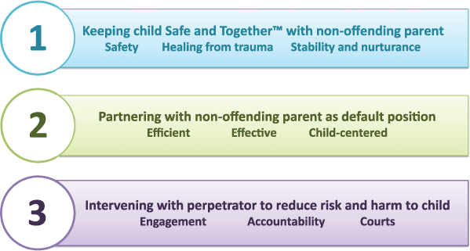

The critical components of the model are outlined below. These components ensure the perpetrator remains visible and removes the potential for ‘mother blaming’ through the identification of domestic and family violence as a parenting choice by the perpetrator.

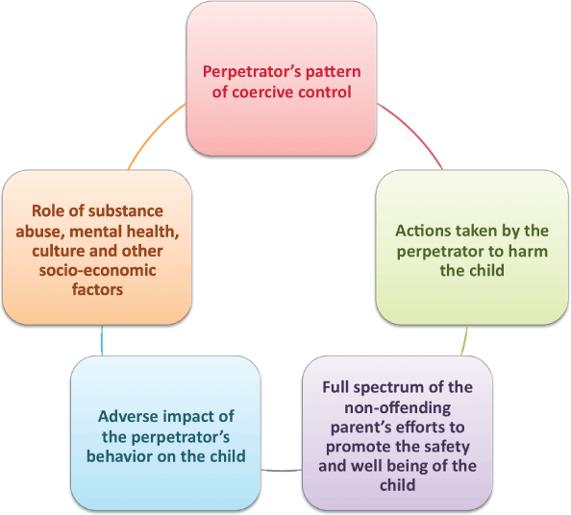

For further reading on the Model, please visit: <https://safeandtogetherinstitute.com/>

# **Contact and Placement Decisions**

**Reflection**

Does your practice include principles from this model? Do your case notes show the pattern and specifics of abuse and the impact on children as in the example below:

‘A’ has a **pattern** of abuse that includes physical violence, threats, damage to property and stopping ‘B’ from seeing family and friends and making derogatory comments to the children. **Specifics** - On four different occasions ‘A’ has assaulted ‘B’, throwing her down and hitting her, resulting in bruises and swelling. On one occasion he smashed ‘B’s mobile phone, punched a hole in the wall and smashed a chair. He has said in front of the children that ‘B’ is stupid and if she tries to leave, he will find her and make her sorry. **Impact on children** – The children have been impacted by the abuse with the youngest bedwetting and scared to leave the mother because something might happen if he’s not here. The eldest is missing school days and repeats the derogatory comments his father has said to ‘B’. He says he doesn’t need to do what his mother says and refuses to participate in sport and after school activities he used to enjoy.

Further reading:

[Characteristics of the Safe and Together Model](https://safeandtogetherinstitute.com/)

Practitioners need to consider the impacts of domestic and family violence when assessing contact and placement issues between a child and parent:

*In fact, women and children may be in greater danger after separation than before. This means that separation from an abusive partner does not always solve the problem of violence in the family. Instead, the nature and the focus of the violence may change and contact visits may well provide the opportunity for the perpetration and perpetuation of abuse* (Rendell, Rathus, & Lynch, 2000, p. 29).

Significantly, at this time of greater danger, there are times when the victim may be expected to negotiate arrangements for contact and residence, either due to extended family pressures, mediation within court actions or child protection case planning decisions. Contact can be used by the perpetrator to continue to engage in violence and abuse of both the non- abusive partner and the children through:

* the use of contact to harass, denigrate and verbally abuse family members
* returning the children in a dirty condition or with inadequate clothing
* making comments and / or threats to the partner via coercion of the children to deliver these messages
* failing to comply with medical and dietary requirements for the children
* failing to meet set guidelines for contact, such as arrangements for visit times, and telephone calls or returning them late from contact
* continuing other abuse of the children, with the non-abusive partner unable to protect them.

Placement decisions may also perpetuate violence. Placing a child with the perpetrator's extended family can exacerbate the violence, increase the child's ongoing exposure to family conflict, and can expose the child to trans-generational domestic and family violence.

Given that a child's exposure to domestic and family violence is recognised and legislated against in the *Domestic and Family Violence Protection Act 2012*, contact and placement arrangements that endanger a child and/ or non-abusive parent need to be identified.

Careful attention needs to be given to developing safe contact arrangements. Where domestic and family violence has been identified it may not be appropriate for parents to share contact visits. Where it has been assessed that a child may be placed at further risk of harm, a rationale to support a no contact decision needs to be well documented in case files. As stated in "An Unacceptable Risk" (Rendell et al., 2000), Family Court orders can impact on this issue also. Amendments to legislation now require the court to consider any existing family law parenting order it is aware of and whether that order needs to be varied or suspended if it is inconsistent with the protection needed by the victim or their children.

# **Priority Populations**

## **Rural and Remote Communities**

The life-changing and debilitating effects of domestic and family violence are exacerbated for those women and children who live in rural or remote locations. Research indicates people living in rural and remote areas, particularly Indigenous communities, experience greater levels of violence generally, and domestic violence specifically, than other areas (Australian Human Rights Commission, 2017). As is the case in urban areas, women experience domestic violence at higher rates than men, but for those in rural and remote areas, further challenges are experienced (Phillips & Vandenbroek, 2014). A publication by the Australian Institute of Family Studies (Campo & Tayton, 2015) identifies a range of compounding and exacerbating factors for women living in regional, remote and rural communities, including the following:

* the lack of availability of independent communication away from the perpetrator due to not having mobile telephone reception or internet access.
* the common presence of firearms.
* in a close-knit, small, conservative community the family may be regarded as ‘upstanding citizens’ who play a key role in the functioning of the community. They may hold positions of power or of social importance which makes disclosure more difficult.
* fear of not being believed or of being ridiculed acts as a barrier to disclosure. Many feel ashamed and humiliated while others are fearful of embarrassing their families who also live in the area.
* a reluctance to contact and use local services due to a traditional ethic of self-sufficiency in these communities. It is possible that the local doctor or police officer is within the same social network, making disclosure extremely difficult.
* social isolation when living on farms and properties away from personal contact with others. Women who have moved with their partners to rural areas may be more isolated, having left behind connections to family, friends and other supports.

When a disclosure is made, further challenges exist in responding to safety concerns. These can include:

* limited access to independent transport and lack of mobile telephone reception, significantly limiting their ability to escape. This can lead to families feeling trapped and isolated.
* familiarity with a family in the community may heighten the reluctance of people in authority, such as a doctor or police officer, to respond appropriately to secure safety.
* slower police response times due to the geographical area police need to service. This may impact on their capacity to arrest and charge a perpetrator who resides in another town. If a victim has tried this avenue with no success, they risk putting themselves in a more dangerous position and may have no other options available.
* difficulty in accessing and enforcing legal protections, such as legal aid, legal representatives, and a timely police response to a breach of a domestic violence order.

People from culturally and linguistically diverse backgrounds have further difficulties in rural areas due to factors including language barriers, lack of familiarity with their surroundings, and the limited opportunities to engage with face to face and telephone interpreters to assist them in accessing supports.

## **Aboriginal and Torres Strait Islander Communities**

Aboriginal and Torres Strait Islander communities have a disproportionately higher rate of assault against women than the non-Indigenous population. Aboriginal and Torres Strait Islander women are 35 times more likely to be hospitalised due to domestic and family violence and are five times more likely to be the victim of domestic homicide than non-Indigenous women (Our Watch, 2014).

Domestic and family violence within these communities is complex and needs to be understood in terms of historical, cultural and social contexts. Colonisation, with its related power and control imbalances, can be regarded as mirroring the dynamics and impacts of family violence. Other factors to take into account include:

* the loss of land and traditional culture
* the disempowerment of traditional elders
* breakdown of community kinship systems
* the breakdown of Aboriginal law
* entrenched poverty, and resultant poor health, education and housing
* racism.

These factors greatly contribute to Aboriginal and Torres Strait Islander families being very suspicious of child safety, police and court systems. Given the experiences of the Stolen Generation, there is a fear that children will be removed from a violent home and not returned, and that responses by the police and the legal system may continue to break down their cultural systems.

The inter-generational trauma that has resulted has led to confusion about roles and cultural identity, internal conflict, and feelings of alienation and anomie. Research has linked the associated suppression or denial of these consequent feelings of distress and despair to their expression through destructive behaviours such as family violence, alcohol and drug abuse, and suicide (Chan & Payne, 2013).

Effective and culturally appropriate engagement with Aboriginal or Torres Strait Islander people is best established by collaborative participation of Aboriginal and Torres Strait Islander practitioners in frontline work. Domestic and family violence in Aboriginal and Torres Strait communities is best approached as a community issue, listening to Elders and all the respected community members.

Further readings:

[Changing the picture: Executive Summary](https://d2bb010tdzqaq7.cloudfront.net/wp-content/uploads/sites/2/2019/11/06021424/Changing-the-picture-exec-summary-AA.pdf)

## **Culturally and Linguistically Diverse Communities (CALD)**

Data in relation to the incidence of domestic and family violence in culturally and linguistically diverse (CALD) communities is problematic and has not been regarded as a true indicator of its prevalence. One study indicated that 7.5% of women from these communities had experienced violence by their partner during the course of their relationship but these statistics are viewed as conservative estimates, due to the many barriers that prevent these families from reporting violence and accessing services or support (Messing, Amanor-Boadu, Cavanaugh, Glass, & Campbell, 2013). Barriers may include:

* language and cultural differences which make communication difficult
* racial judgements and discrimination, particularly made against women from CALD backgrounds married to Australian men
* pre- and post-migration experiences which may include torture and trauma, cultural shock, grief and loss for family and previously known network systems
* differences in gender roles, cultural values and traditions impacting on freedom, rights and opportunities
* the role of the mother in many cultures in maintaining the family’s unity and keeping the family’s honour, therefore counteracting disclosure
* fear for the possible fragmentation of the family unit
* isolation due to separation from extended family and other support networks
* a lack of knowledge and understanding of Queensland systems and services
* fear of government departments, correlating them to past experiences of police, military or paramilitary actions as is particularly relevant to people who are refugees
* hesitation in seeking help from their own community due to cultural taboos, social stigmas, shame, fear, and privacy issues
* threats to cancel their visas or withdraw permanent residency applications with the Department of Immigration and Multicultural Affairs, where applicable, should the partner try to leave the relationship
* a lack of access to services which can respond to their needs.

Women from culturally and linguistically diverse backgrounds frequently do not speak up about domestic violence due to different perceptions and understandings as to what constitutes domestic violence. In some communities, domestic violence is not seen as including emotional, psychological and sexual abuse. Some women can assume that violence, in some form or the other, is the right of her husband as the head of the family and the sole breadwinner. (Dedeigbo & Cocodia, 2016).

Children from culturally and linguistically diverse communities require and are entitled to the same protections from harm as any other child. It is unacceptable to not intervene in families from different cultural backgrounds by presuming that the violence or harm is a culturally sanctioned belief or practice.

To ensure effective communication is achieved, professional interpreters should be engaged, even when the person may have some understanding of English as a second language. Culturally appropriate protocols and procedures also need to be taken into account. Contact with support services, such as the Immigrant Women’s Support Service can assist in gaining further understanding. It is important that confidentiality be maintained during this contact, as a family may fear that their situation will become known to their own specific cultural community.

Further readings:

[CALD, migrant and refugee experiences of violence](https://www.1800respect.org.au/workers/cald/)

[DFV resources in a variety of languages](https://www.healthtranslations.vic.gov.au/bhcv2/bhcht.nsf/PresentDetail?Open&s=Domestic_and_family_violence_factsheet)

## **Women who Experience Disability**

While research concerning the prevalence and nature of violence perpetrated against women with disabilities is limited, current research reveals that women with disabilities are 40 percent more likely to be victims of domestic and family violence than other women, and more than 70 percent of women with disabilities have been victims of violent sexual encounters at some point in their lives (Frohmader, Dowse, & Didi, 2015). Additionally, almost all Australian women with an intellectual disability (90%) have been subjected to sexual abuse, with more than two-thirds (68%) having been sexually abused before they turn 18 years old (Australian Law Reform Commission 2010, in Frohmader et al., 2015). It is also widely recognised that the actual prevalence rates of violence against women with disabilities is likely higher than the available data indicates; due both to under-reporting, and systemic discrimination which often dismisses or ‘covers-up’ disclosures of domestic and family violence from women with disabilities (Frawley, Dyson, Robinson, & Dixon, 2015; Frohmader et al., 2015).

Although women with disabilities experience many of the same forms of violence that all women experience, research suggests that intersecting discriminations sometimes result in additional, unique types of abuse. These can include:

* institutional violence;
* forced or coerced contraception and sterilisation;
* forced or coerced psychiatric interventions;
* withholding of, or forced medication and medical exploitation;
* violation of privacy;
* deprivation of liberty; and
* denial of essential care (Frawley et al., 2015).

Perpetrators of violence may manipulate the impact of a person’s disability as a means of increasing power and control over the victim. For women in institutional settings whose autonomy has already been restricted, the impacts of these methods of manipulation are particularly acute, creating significant barriers to seeking help or to disclosing violence (Dowse, Soldatic, Spangaro, & van Toorn, 2016).

# **Resources**

It is important that as workers you are able to identify and connect to, or refer the carer, mother, child or father to the appropriate domestic and family violence supports. There is specialist support available throughout Queensland and it is now easy to find what is available.

A directory of support services and contacts is available on the following two websites:

[DFV services](https://www.qld.gov.au/community/getting-support-health-social-issue/support-victims-abuse/domestic-family-violence/find-local-support)

[1800 RESPECT](https://www.1800respect.org.au/)

Information on Domestic and Family Violence information and publications can be accessed on these links:

[Domestic and family violence resources](https://publications.qld.gov.au/dataset/domestic-and-family-violence-resources) [ANROWS](https://anrows.org.au/)

[Our Watch](https://ourwatch.org.au/)

Safe & Together Institute

# **References**

Australia’s National Research Organisation For Women’s Safety. (2016). Violence against women: Key statistics. Sydney, NSW: Australia’s National Research Organisation for Women’s Safety. Retrieved from [http://anrows.org.au/sites/default/files/Violence-Against-Australian-Women-Key- Statistics.pdf](http://anrows.org.au/sites/default/files/Violence-Against-Australian-Women-Key-%20Statistics.pdf)

Australian Bureau of Statistics. (2017). Personal Safety Survey 2016. ABS cat. No. 4906.0. Canberra, ACT: ABS.

Australian Bureau of Statistics. (2013). Personal safety survey 2012. Canberra: Australian Bureau of Statistics.

Australian Human Rights Commission. (2017). A conversation in gender equality. Sydney, NSW: Australian Human Rights Commission. Retrieved from [https://www.humanrights.gov.au/sites/default/files/document/publication/AHRC_conversation_gend er_equality_2017_2.pdf](https://www.humanrights.gov.au/sites/default/files/document/publication/AHRC_conversation_gend%20er_equality_2017_2.pdf).

Campo, M. (2015). Domestic and family violence in pregnancy and early parenthood: Overview and emerging interventions. Melbourne, Vic: Australian Institute of Family Studies. Retrieved from <https://aifs.gov.au/cfca/sites/default/files/publication-documents/cfca-resource-dv-pregnancy.pdf>.

Campo, M., & Tayton, S. (2015). Domestic and family violence in regional, rural and remote communities: An overview of key issues. Melbourne, Vic: Australian Institute of Family Studies Retrieved from [https://aifs.gov.au/cfca/sites/default/files/publication-documents/cfca-resource-dv- regional.pdf](https://aifs.gov.au/cfca/sites/default/files/publication-documents/cfca-resource-dv-%20regional.pdf)

Chan, A., & Payne, J. (2013). Homicide in Australia: 2008-2009 to 2009-2010, National Homicide Monitoring Program annual report. Canberra: Australian Institute of Criminology. Retrieved from <http://www.aic.gov.au/publications/current%20series/mr/21-40/mr21.html>.

Clements, P. T., Holt, K. E., Hasson, C. M., & Fay-Hillier, T. (2011). Enhancing assessment of interpersonal violence (IPV) pregnancy-related homicide risk within nursing curricula. Journal of Forensic Nursing, 7(4), 195-202. doi:10.1111/j.1939-3938.2011.01119.x

Cox, P. (2015). Additional analysis of the Australian Bureau of Statistics' Personal Safety Survey. Sydney, NSW: Australia's National Research Organisation for Women’s Safety.

Dedeigbo, O., and Cocodia, E. (2016) Domestic violence in Australia's CALD communities: Association between demographics of frontline workers and selected therapeutic approaches. Proceedings of the 3rd Asia Pacific Conference on Advanced Research. Retrieved from http://apiar.org.au/?conference-paper=domestic-violence-in-australias-caldcommunities-association- between-demographics-of-frontline-workers-and-selectedtherapeutic-approache s

Department for Child Protection. (2013). Perpetrator accountability in child protection practice: A resource for child protection workers about engaging and responding to perpetrators of family and domestic violence. Perth, WA: Western Australian Government.

Domestic Abuse Intervention Programs. (2017). Wheels. Retrieved from <https://www.theduluthmodel.org/wheels/>

Dowse, L., Soldatic, K., Spangaro, J., & van Toorn, G. (2016). Mind the gap: The extent of violence against women with disabilities in Australia. Australian Journal of Social Issues, 51(3), 341-359. doi:10.1002/j.1839-4655.2016.tb01235.x

Frawley, P., Dyson, S., Robinson, S., & Dixon, J. (2015). What does it take? Developing informed and effective tertiary responses to violence and abuse of women and girls with disabilities in Australia (State of knowledge paper). Sydney, NSW: Australia's National Research Organisation for Women's Safety. Retrieved from <https://anrows.org.au/sites/default/files/3_3.4%20Landscapes%20Disability.pdf>.

Frohmader, C., Dowse, L., & Didi, A. (2015). Preventing violence against women and girls with disabilities: Integrating a human rights perspective. Think piece document for the development of the National Framework to Prevent Violence Against Women. Lenah Valley, Tasmania: Women With Disabilities Australia. Retrieved from [http://wwda.org.au/wp-content/uploads/2015/04/Think- Piece_WWD.pdf](http://wwda.org.au/wp-content/uploads/2015/04/Think-%20Piece_WWD.pdf)

Garcia-Moreno, C., Guedes, A., & Knerr, W. (2012). Understanding and addressing violence against women: Intimate partner violence. Washington, DC: World Health Organisation. Retrieved from <http://apps.who.int/iris/bitstream/10665/77432/1/WHO_RHR_12.36_eng.pdf>.

Hooker, L., Kaspiew, R., & Taft, A. (2016). Domestic and family violence and parenting: Mixed methods insights into impact and support needs (State of knowledge paper). Sydney, NSW: Australia’s National Research Organisation for Women’s Safety. Retrieved from <https://d2c0ikyv46o3b1.cloudfront.net/anrows.org.au/s3fs-public/L1.16_1.8%20Parenting.pdf>.

Humphreys, C. (2007). Domestic violence and child protection: Exploring the role of perpetrator risk assessments. Child & Family Social Work, 12(4), 360-369. doi:10.1111/j.1365-2206.2006.00464.x

Malchiodi, C. A. (2015). Neurobiology, creative interventions, and childhood trauma. In C. A. Malchiodi (Ed.), Creative interventions with traumatised children (2nd ed., pp. 3-23). New York, NY: The Guilford Press.

Malone, U., & Phillips, J. (2014, May 6). Domestic violence of epidemic proportions a ‘national emergency’: Campaign groups. ABC News. Retrieved from [http://www.abc.net.au/news/2014-05- 05/domestic-violence-reaches-epidemic-proportions/5426214](http://www.abc.net.au/news/2014-05-%2005/domestic-violence-reaches-epidemic-proportions/5426214)

Mandel, D. (2017). Why is the Safe and Together Model relevant for welfare workers. Retrieved from: [http://endingviolence.com/our-programs/safe-together/faq/why-is-the-safe-and-together-model- relevant-for-child-welfare-workers-2/](http://endingviolence.com/our-programs/safe-together/faq/why-is-the-safe-and-together-model-%20relevant-for-child-welfare-workers-2/)

McMahon, S., & Armstrong, D. Y. (2012). Intimate partner violence during pregnancy: Best practices for social workers. Health & Social Work, 37(1), 9-17. doi:10.1093/hsw/hls004

Menezes Cooper, T. (2013). Domestic violence and pregnancy: A literature review. International Journal of Childbirth Education, 28(3), 30-33. Retrieved from <https://search.proquest.com/docview/1412227147?pq-origsite=gscholar>

Messing, J. T., Amanor-Boadu, Y., Cavanaugh, C., Glass, N., & Campbell, J. (2013). Culturally competent intimate partner violence risk assessment: Adapting the danger assessment for immigrant women. Social Work Research, 37(3), 1-13. doi:10.1093/swr/svt019

Mitra, M., Manning, S., & Lu, E. (2012). Physical abuse around the time of pregnancy among women with disabilities. Maternal & Child Health Journal, 16(4), 802-806. doi:10.1007/s10995-011-0784-y

Morris, A., Humphreys, C., & Hegarty, K. (2015). Children's views of safety and adversity when living with domestic violence. In N. Stanley & C. Humphreys (Eds.), Domestic violence and protecting children: New thinking and approaches (pp. 18-33). London, UK: Jessica Kingsley Publishers.

National Sexual Assault and Domestic Family Violence Counselling Service. (2015). Domestic and family violence: What is it and where do I find support? Retrieved from <https://www.1800respect.org.au/get-help/common-questions/what-is-domestic-family-violence/>

O'Reilly, R. (2007). Domestic violence against women in their childbearing years: A review of the literature. Contemporary Nurse, 25(1-2), 13-21. doi:10.5555/conu.2007.25.1-2.13

Our Watch. (2014) Reporting on Family Violence in Aboriginal & Torres Strait Islander Communities. Retrieved from [https://www.ourwatch.org.au/MediaLibraries/OurWatch/Images/ourwatch_reporting_on_a- ts_family_violence_aa_v1.pdf](https://www.ourwatch.org.au/MediaLibraries/OurWatch/Images/ourwatch_reporting_on_a-%20ts_family_violence_aa_v1.pdf)

Phillips, J., & Vandenbroek, P. (2014). Domestic, family and sexual violence in Australia: An overview of the issues (Parliamentary Library research paper). Canberra, ACT: Department of Parliamentary Services, Australian Government. Retrieved from <http://parlinfo.aph.gov.au/parlInfo/download/library/prspub/3447585/upload_binary/3447585.pdf>

Queensland Government. (2016a). Domestic and Family Violence Prevention Strategy 2016-2026. Brisbane, Qld: Queensland Government.

Queensland Government. (2016b). Queensland says: Not now, not ever. Domestic and family violence prevention strategy 2016-2026. Brisbane, Qld: Queensland Government.

Queensland Government (2017a) 'Support someone experiencing domestic and family violence. Retrieved from https://www.qld.gov.au/community/getting-support-health-social-issue/support- domestic-family-violence-victim

Queensland Government. (2017b). Domestic and Family Violence Death Review and Advisory Board 2016-17 Annual Report

Queensland Government. (2017c). Domestic and Family Violence Information Sharing Guidelines. 2017 (Department of Communities, Child Safety and Disability Services)

Rendell, K., Rathus, Z., & Lynch, A. (2000). An unacceptable risk: A report on child contact arrangements where there is violence in the family Annerley, Qld: Women's Legal Service.

Victorian Department of Human Services. (2012). Family Violence Risk Assessment and Risk Management Framework and Practice Guides 1-3. Melbourne, Victoria: Victorian Department of Human Services.

White Ribbon Australia. (2017). Understand domestic violence - Violence against men. Retrieved from <https://www.whiteribbon.org.au/understand-domestic-violence/violence-against-men/>

